Data collection

ADMISSION INQUIRY
Program Offered:-
Academic Program Offered
Sr. No. | Course Name | Sanction Intake | General Choice Code | Duration
1 | Artificial Intelligence & Data Science | 120 | 541826310 | 4 Year
2 | Automation & Robotics | 60 | 541891610 | 4 Year
3 | Civil Engineering | 60 | 541819110 | 4 Year
4 | Computer Engineering | 120 | 541824510 | 4 Year
5 | Electrical Engineering | 60 | 541829310 | 4 Year
6 | Mechanical Engineering | 60 | 541861210 | 4 Year
7 | Bachelor of Business Administration (BBA) | 60 | 541810110 | 3 Year
8 | Master of Business Administration (MBA) | 120 | 541810110 | 2 Year
9 | ME Computer (AI & DS) | 12 | 541894310 | 2 Year
10 | ME Mechanical (Automation & Robotics) | 12 | 541895610 | 2 Year

Admission process:
First Year Engineering Admission Process
Eligibility :(For updates refer to www.mahacet.org)

Direct Second Year Engineering Admission
Eligibility :(For updates refer to www.mahacet.org)

Document Required:-
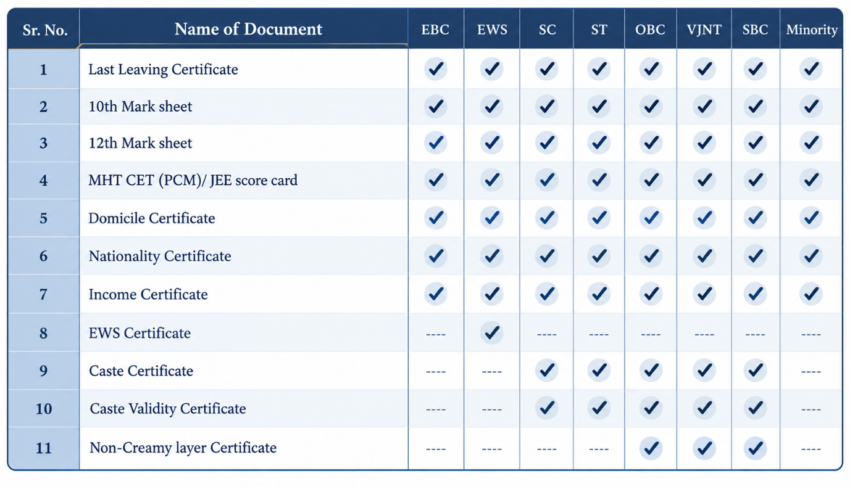

Seat Matrix:
Guru Gobind Singh College of Engineering & Research Centre, Nashik | GCOERC
Year of Establishment | Intake | Location | Contact No.
2022-23 | 30 | Fourth Floor , GCOERC Building | 7768004583
2023-24 | 60 | Fourth Floor , GCOERC Building | 7768004583
2024-25 | 60
2025-26 | 120
Artificial Intelligence and Data Science (AI & DS), aims the students to acquire technical skills to perform data processing, analysis and visualization in multiple real-time applications. Program mainly focus on students with the ability to identify and assess social ,Ethical, safety and cultural issues with an emphasize on identifying their consequent responsibilities as engineers of offering optimal and effective solutions for the same.
The curriculum of this programme is interdisciplinary at the core – straddling computer Science blended with Mathematical Foundations, Artificial Intelligence Techniques, Machine Learning Principles, Statistical Methods, Data Science Philosophies, and their applications across multiple domains. Curriculum also covers on sub-field such as Big Data Analytics, Deep Learning and Computer Vision and Pattern Recognition .

Computer Center

The computer center at the institution aims to provide state-of-the-art computing facility to the college community. The beautifully arranged systems facilitate ease and conducive working atmosphere for the staff and students of this organization. The Centre has a dedicated Internet link.
Wi-Fi allows all students to access a range of services across our entire campus including all computer labs.
The system configuration is Lenovo All in One Machine M72Z Dual Core processor with 2GB RAM & 500GB HDD. Sophisticated and latest software has been purchased to enable the faculty as well as students to pursue their research / project works. Software and packages as per norms of AICTE and Pune University are loaded.
Along with this the computer center provides facilities for scanning & printing of documents.
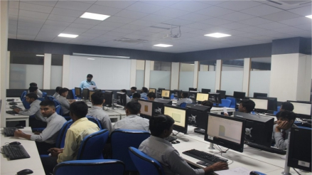
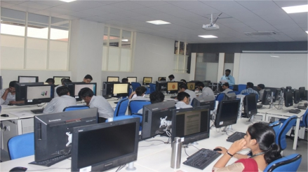

Sports

Our college has a tradition of providing an all-round development for students, by making available facilities for sports . The college has very good infrastructural facilities for sports and related extra-curricular activities, which have been developed and have thrived over the years. There have been additions to and renovations of these facilities from time to time, for indoor and outdoor games and also for the traditional Indian games. The last THREE years has seen an increase in participation of ourstudents in sports at all levels (University, Inter-zonal, Intercollegiate, State and National). Students have won medals invarious events on different Sports activities have improved significantly. with the Director of Physical Education actively promoting indoor and outdoor games. Several students have participated in games at the Zonal, State and National levels and won accolades for the same.
Sports Photographs
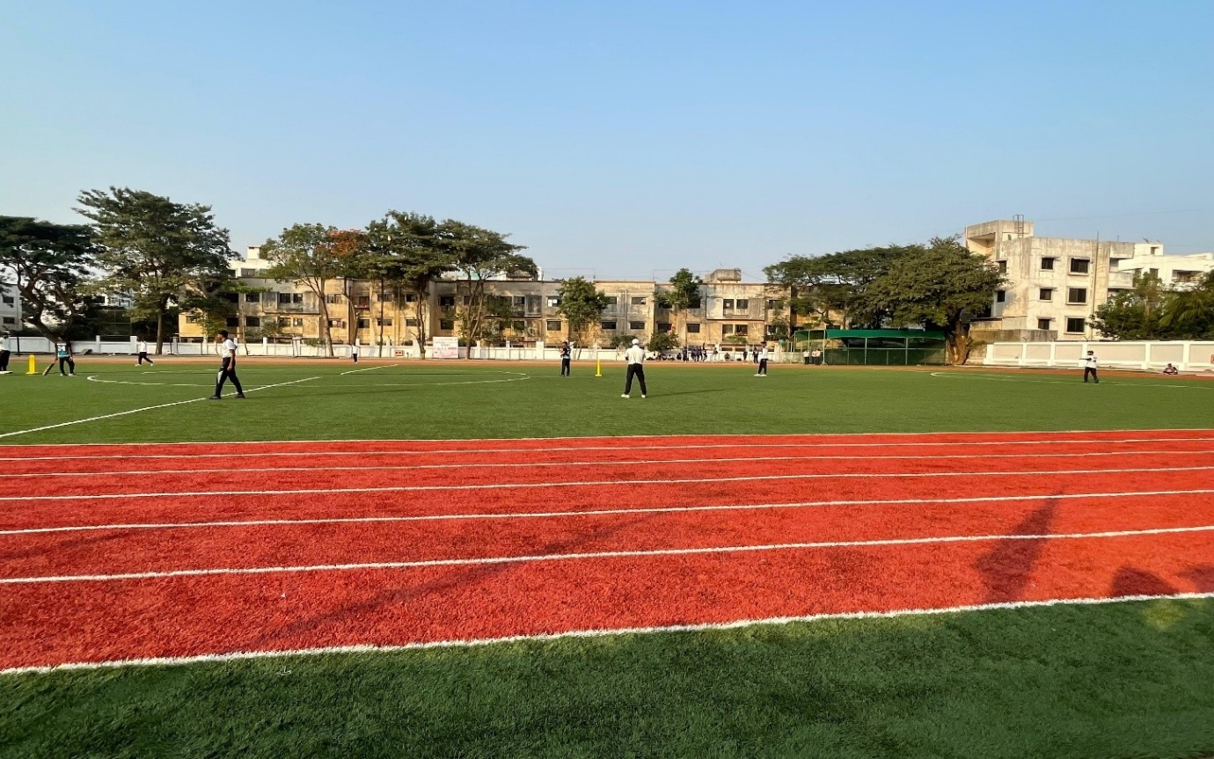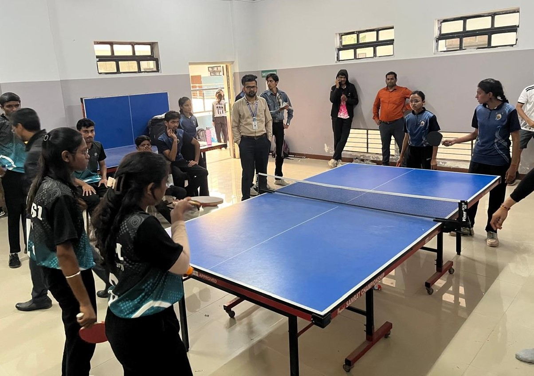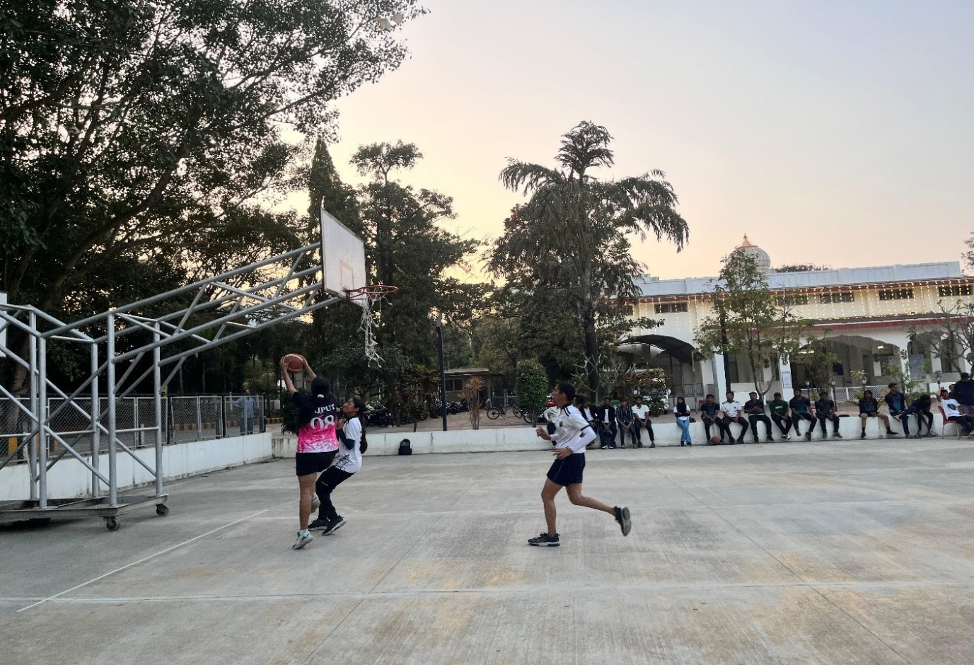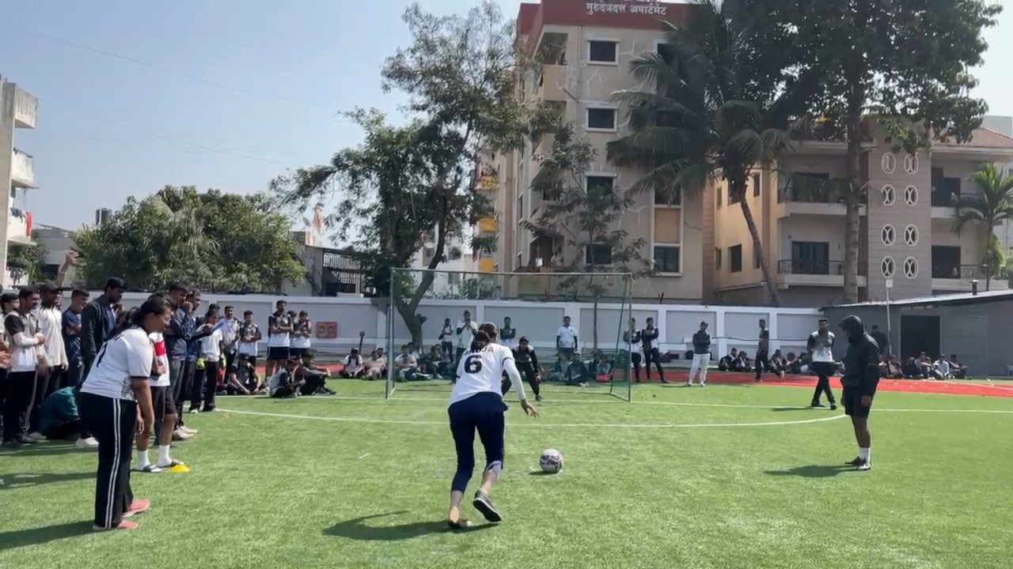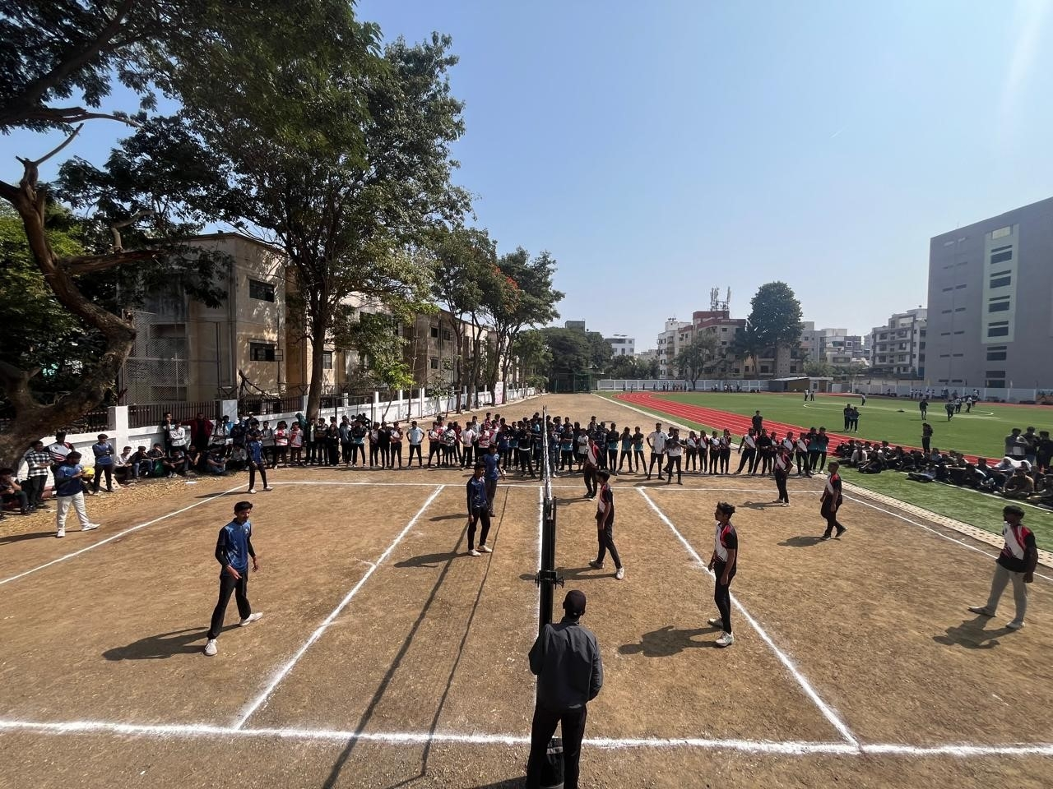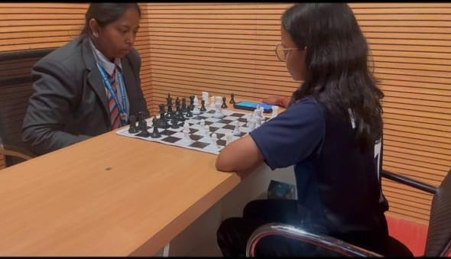
Sports Reports
- Sports Report 2025-26
- Sports Report 2024-25
- Sports Report 2023-24
- Sports Report 2022-23
Facility :-
Outdoor Games
Institute has provided facilities for outdoor games like Kho-Kho, Handball, volleyball etc. within the campus.
Sr.No. | Facility | Description
01 | Basket Ball Court | Common facility provided by GGSF
02 | Volley Ball Court | Common facility provided by GGSF
03 | Play Ground | Common facility provided by GGSF
04 | Kho-Kho Ground | Common facility provided by GGSF
05 | Kabaddi Ground | Common facility provided by GGSF
06 | Cricket Turf for net practice | 4 nos, Common facility provided by GGSF
07 | Yoga Centre | 1 Yoga Hall of an Area with a facility of Audio and Video Presentations
Indoor Games/ Facilities:
Indoor game facilities like table tennis, chess are provided by the institute the details of which are given below:
Sr.No. | Facility | Description
01 | Table Tennis | 4 no of sets are available
02 | Chess | 04 no of sets are available
03 | Carrom | 10 no of sets are available
04 | Gymnasium equipment is available

CANTEEN
Cafeteria
College has a spacious cafeteria. At the cafeteria, dishing out menus is highly popular among students as well as staff. Students enjoy their food in the clean, well maintained, aesthetic and appetizing atmosphere. Most people fondly remember their college cafeteria as one of their life’s high points It is the place where they keep their creative juices flowing with hot discussions, chewing ideas, exchanging and sharing strongly held opinions and eatables.
Kitchen staff takes care to provide the students and staff a nutritious and hygienic food at our campus cafeteria. A variety of hygienic food and snack items includes South and North Indian Meals, Variety Rice dishes, Chat, Chinese Foods, Fresh Juices, Fruits, Ice Creams, etc. Facility of Nescafe kiosk is also available.
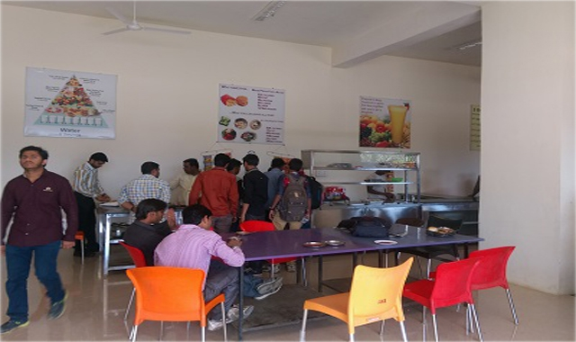

Canteen Photographs
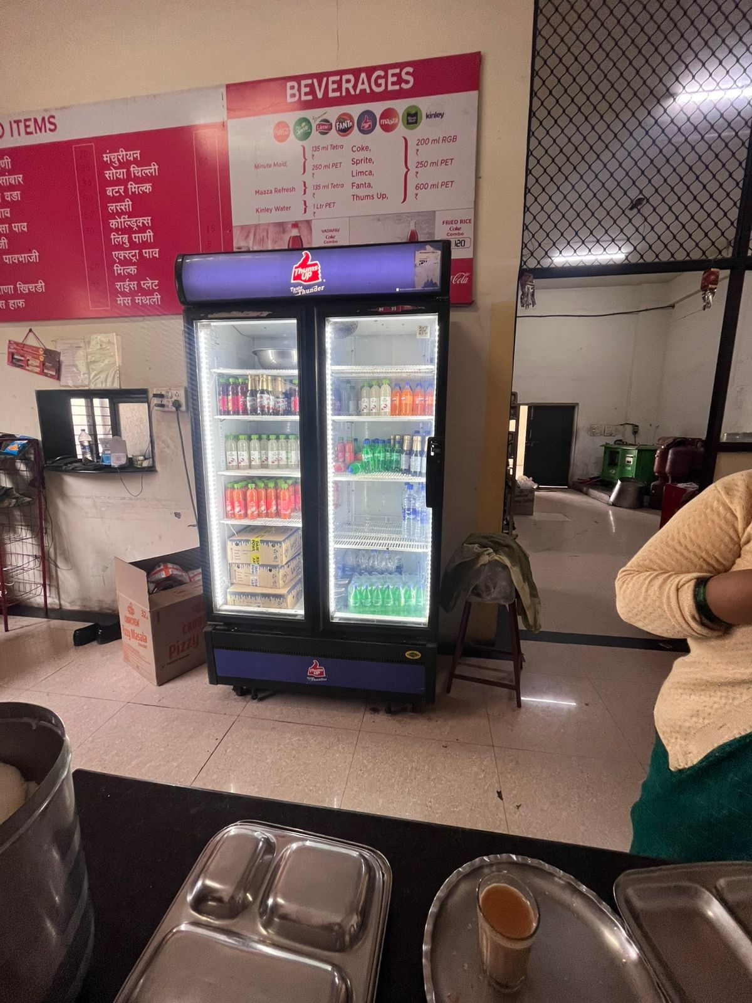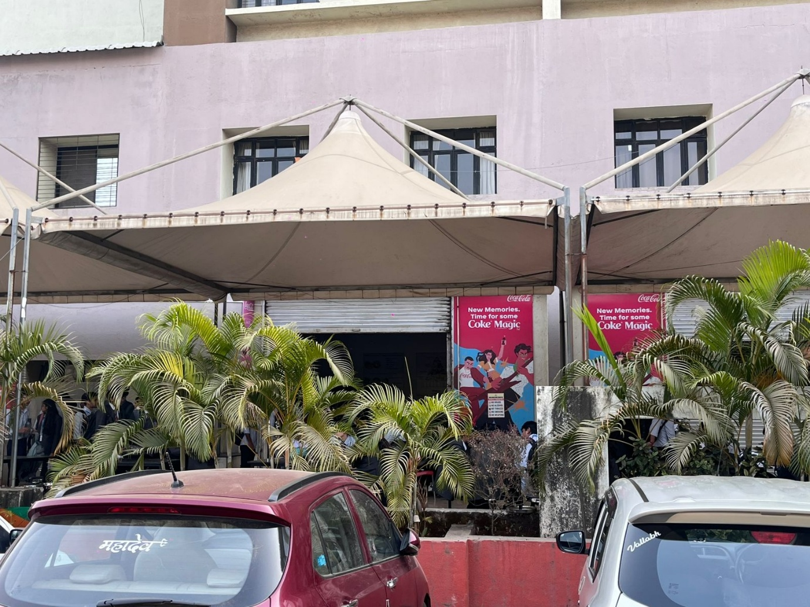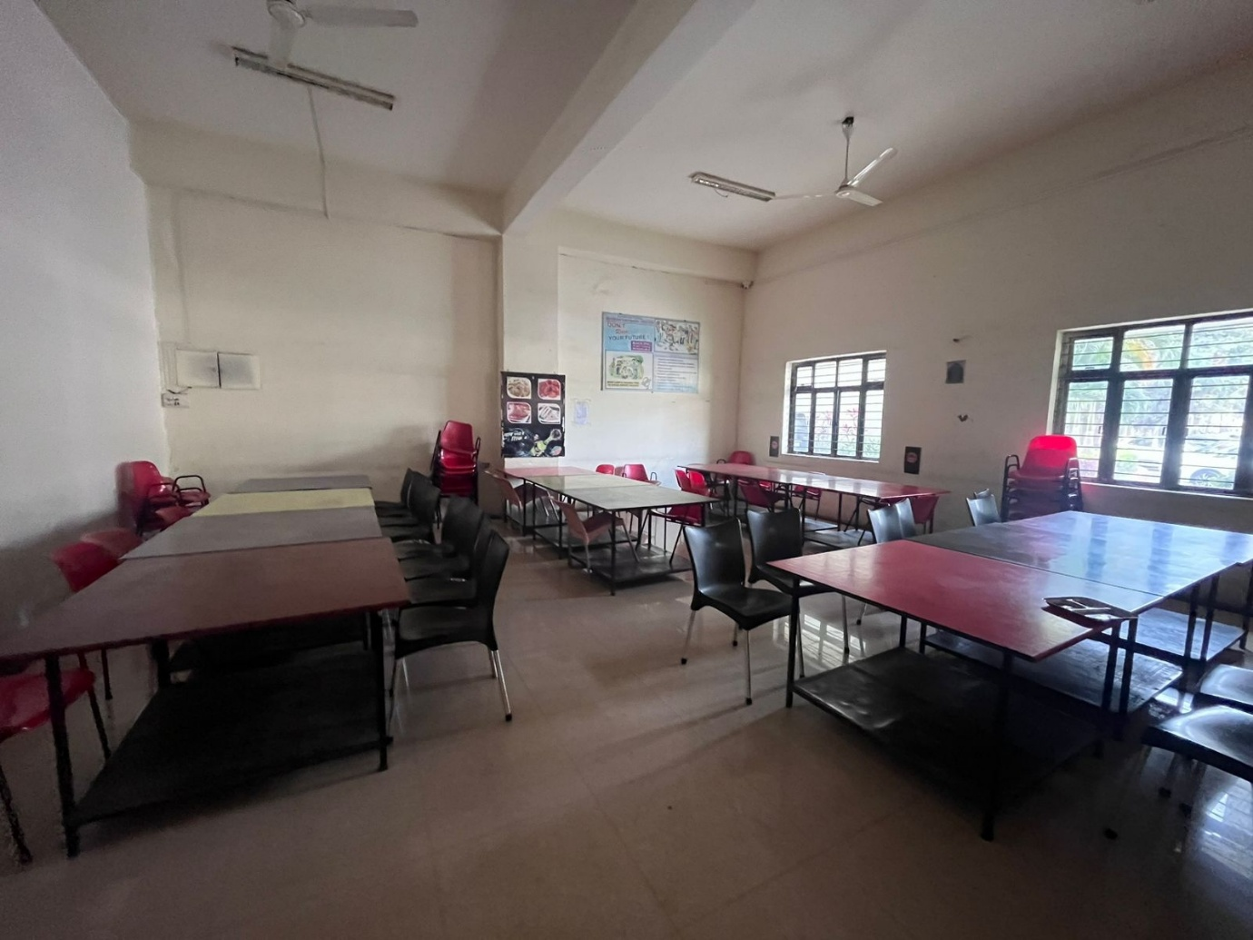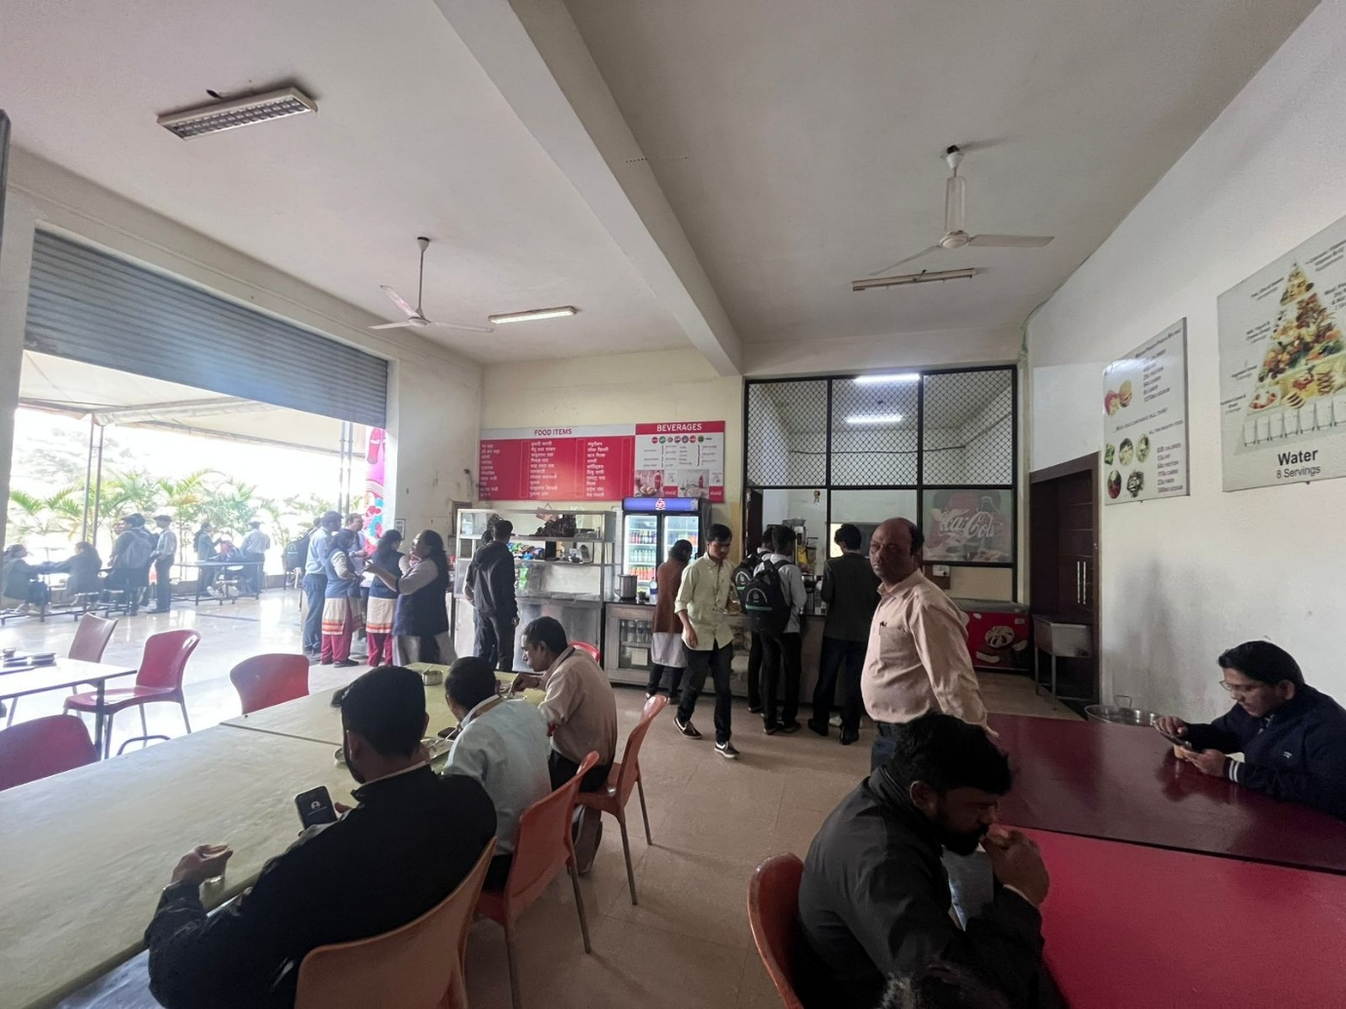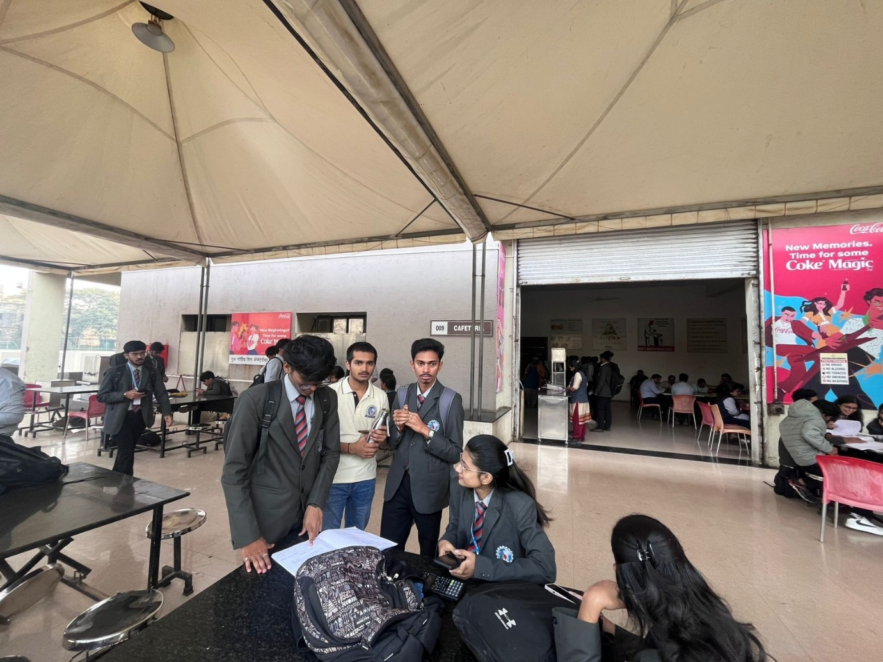

HEALTH CARE
Guru Gobind singh Foundation provides medical facilities in & outside the campus for its Employees and students in association with Following Hospitals.
- Sahyadri Speciality Hospital, Nashik
Contact: 0253-2599300 / 6691666
https://sahyadrihospital.com/nashikadmin@sahyadrihospitals.com
- Ashoka Medikover Hospitals, Nashik
Contact: 0253-6660 000 ,0253- 6660 066 info@medicoverhospitals.cin
- Appollo Hospitals ,Nashik Contact: 91-253-2510250/350/450/550/750 apollonashik@apollohospitals.com
- In Addition to this GGSF also has renown Cardiologist Dr. Abhay Singh Walia as a Medical Counselor of Institute.

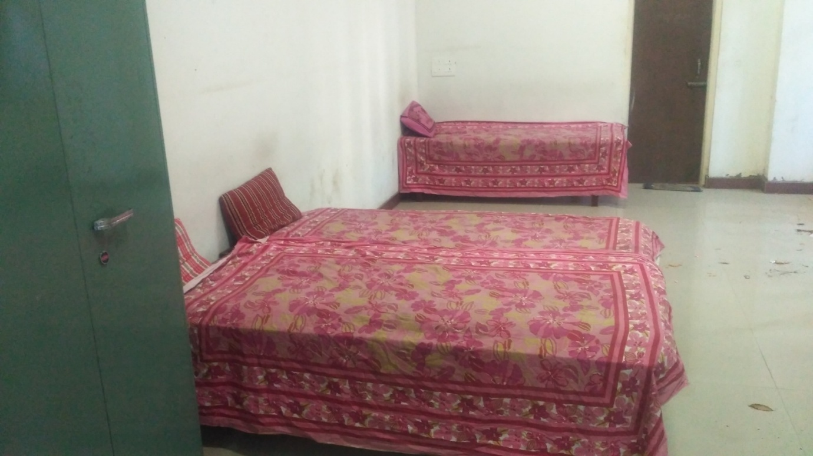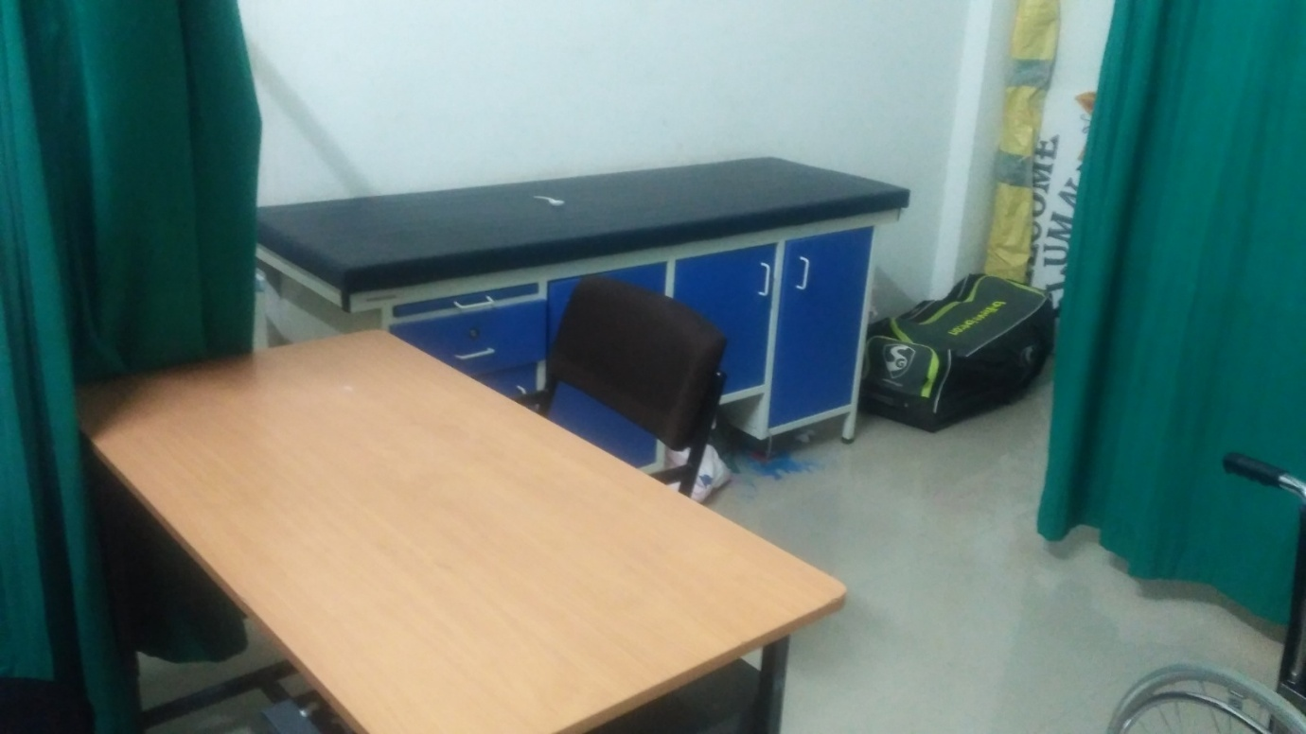

AUDITORIUM & SEMINAR HALL

The Auditorium
State-of-the-art auditoriums with good seating capacity that act as a common ground for students, faculty, and corporate personalities for regular interfaces, conferences and other events. For events of a smaller scale, the Seminar Halls, equipped with advanced presentation tools, are the ideal venue.The auditorium, with a seating capacity of 400 and centrally air-conditioning. Equipped with modern facilities like multimedia projector and sound systems, the auditorium has large lobbies and verandahs ideally suited to hold International Conferences and Exhibitions.

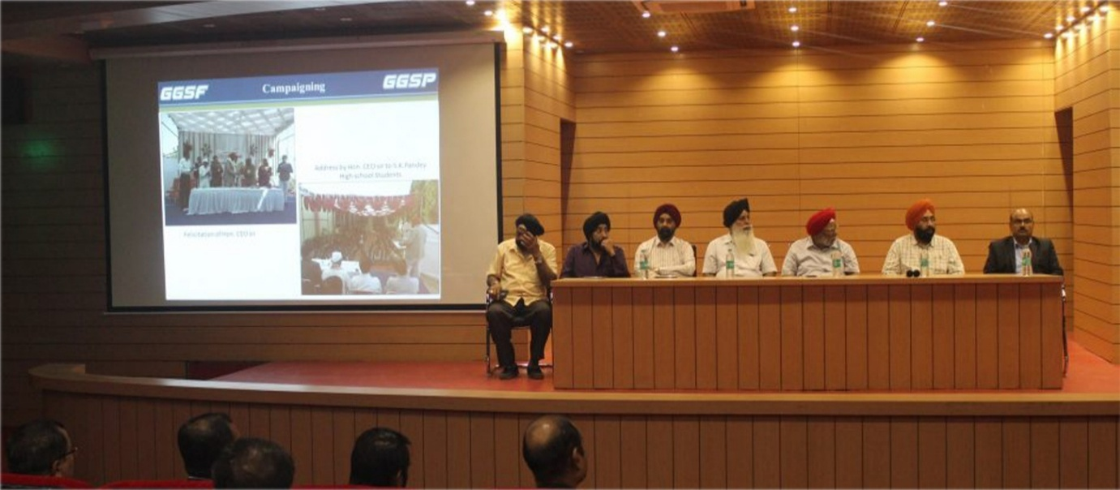

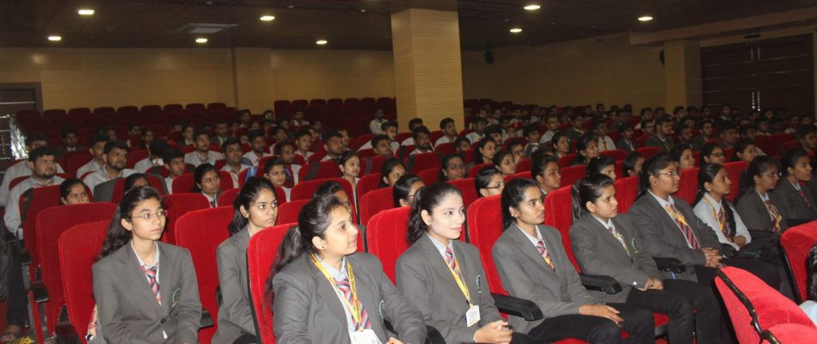

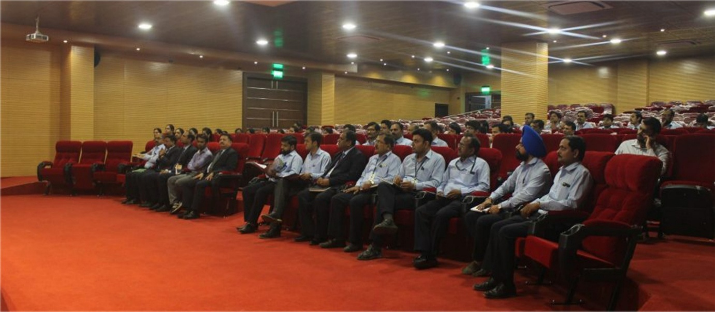

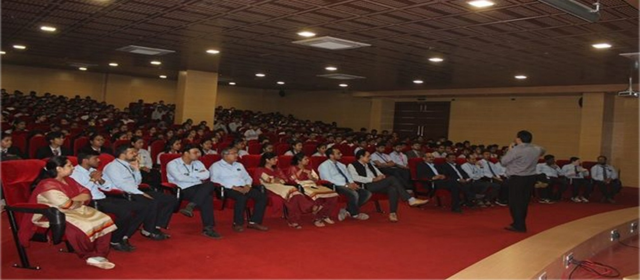

The Seminar Hall

The institute has the proud distinction of maintaining of fully equipped seminar hall with modern audio-visual aids. Besides hosting the monthly student assemblies addressed by the Principal & Faculty in order to interact with the students, the seminar hall also hosts various academic activities, extension lectures, educational and training programs for the students and faculty. The conferences and lectures not only provide the students with a first hand information about the working of various fields but also gives them an opportunity to get their doubts cleared by asking more and more questions from the faculty members and the Principal as well.

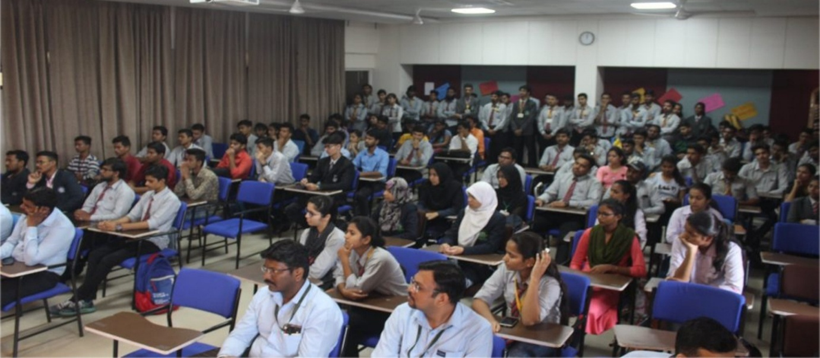

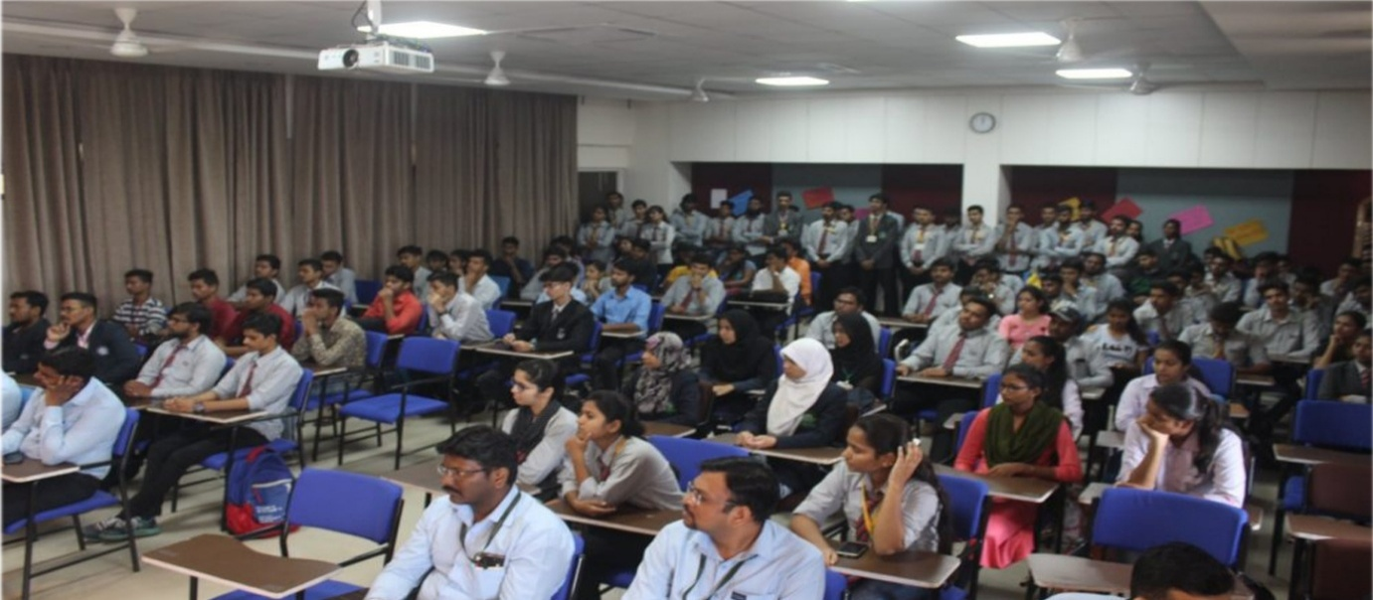

Green Initiatives / Practices

The objective of adopting green practice in the campus is to upgrading the environment condition in and around the institute. It is carried out by adopting following practices.

- Public Transport:
Although college has provided bus facility for students, few of our students avail public bus facility provided by Nasik Municipal Corporation
- Pedestrian friendly roads
Pedestrian friendly roads are available in college campus to provide pleasant walking environment in the campus. These are easy to clean and maintain. Dustbins are placed along these pedestrian friendly roads to keep the campus clean.
- Green landscaping with trees and plants
The college is well land scape with trees and plants, Tree plantation an important responsibility is handled with due care by planting good number of trees by Staff members and NSS students every year at and off the campus. By organizing these tree plantation institute contributes to the “Vanamohtsava Drive” of state government. Staff is appointed for taking care of trees and gardens. Institute follows regular practice for the felicitation of invited guest by presenting saplings and books instead of bouquet.
- Tree Plantation
As per the circular of Government of Maharashtra about plantation of 2 crore trees, We Guru Gobind Singh College of Engineering and Research Centre, Nasik is organized Tree Plantation Day program in collaboration with Shree Bharat Co-Op Group Housing Society Ltd, Nasik. We have planted various types of trees in college campus & nearby college campus some of them being Gulmohar, Nilmohar, Chafa, Raktchandan, Mango, Shankasur etc. For tree plantation total 190 all department students, staff members are participated.
- Use of renewable energy:
Institute has installed solar panel to partially meet lighting requirement by solar energy Solar street lights are installed at parking areas.
- Water harvesting:
The institute has implemented rain-water harvesting, which significantly contributed to increasing ground water table and reduce water expenses.

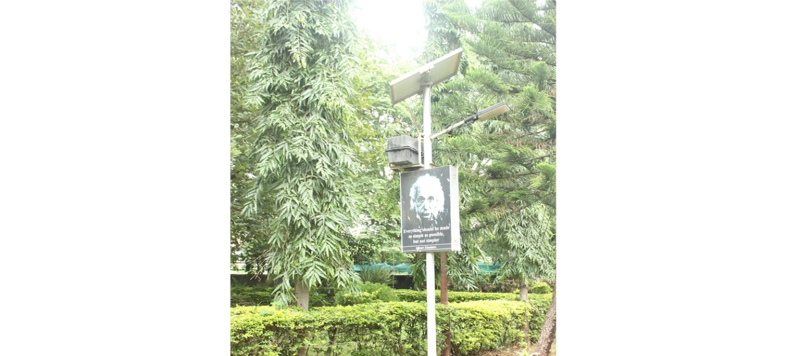

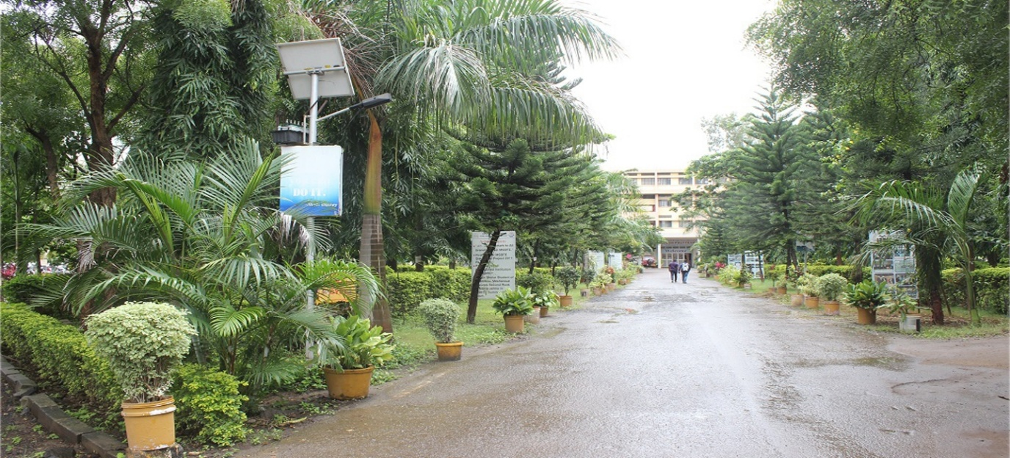

DIVYANGJAN FRIENDLINESS
Resources available in the institution for Divyangjan
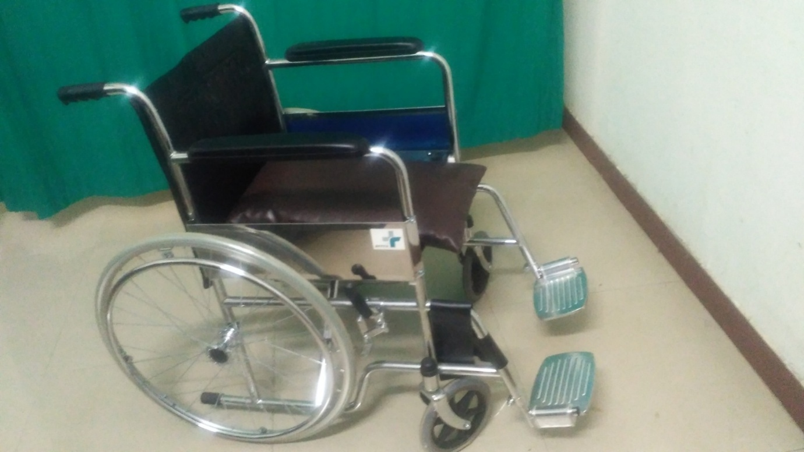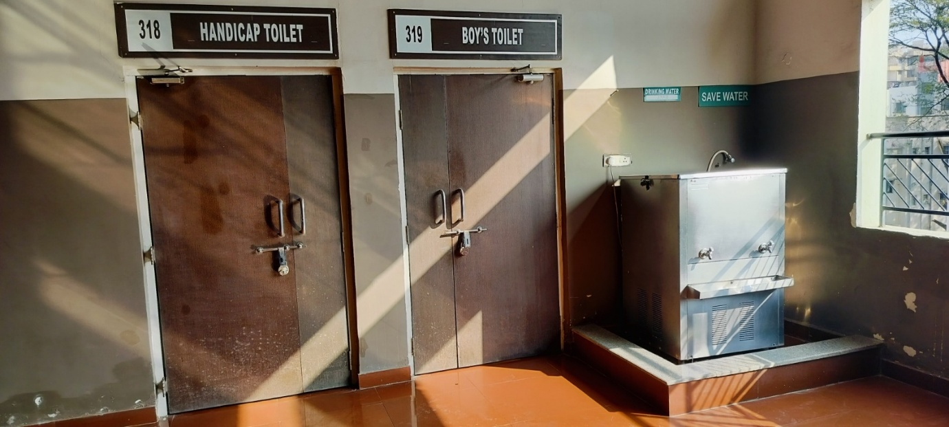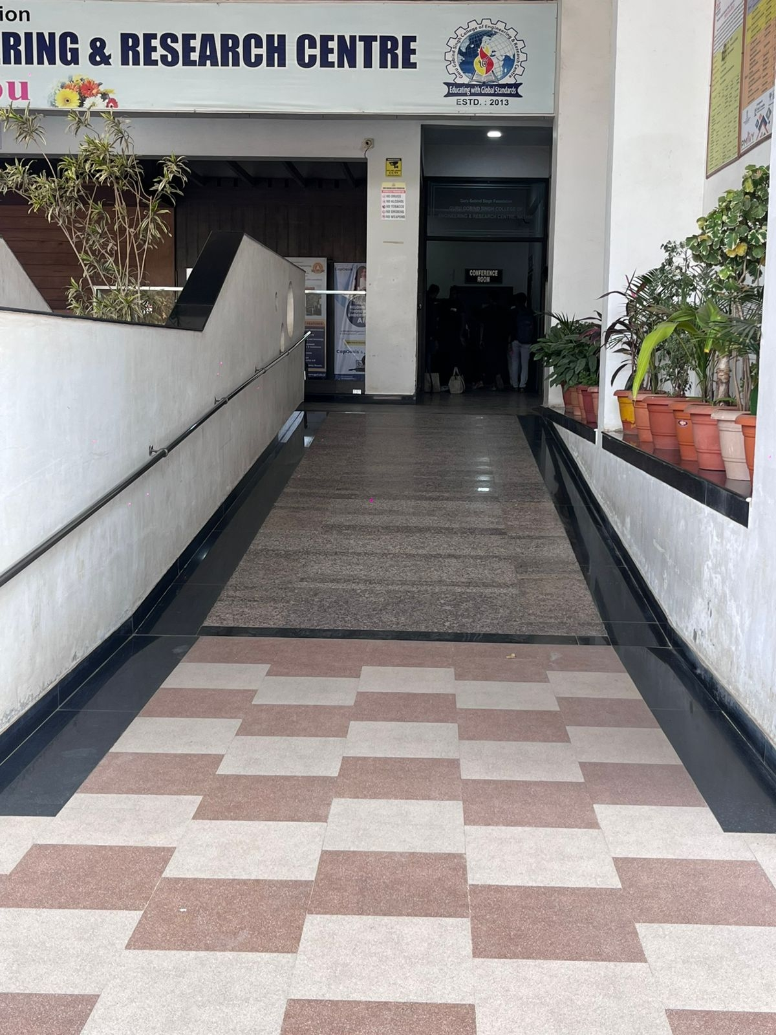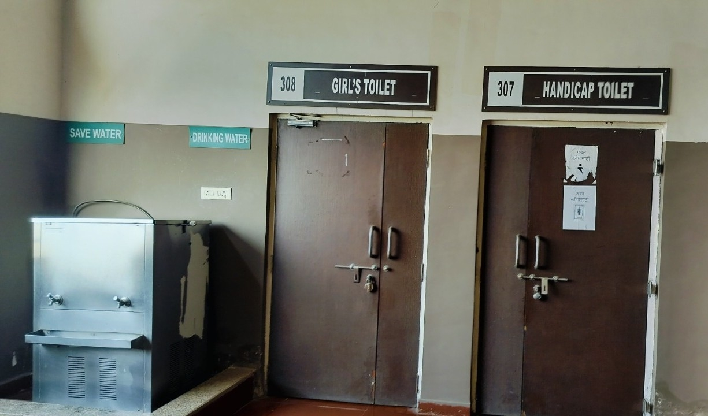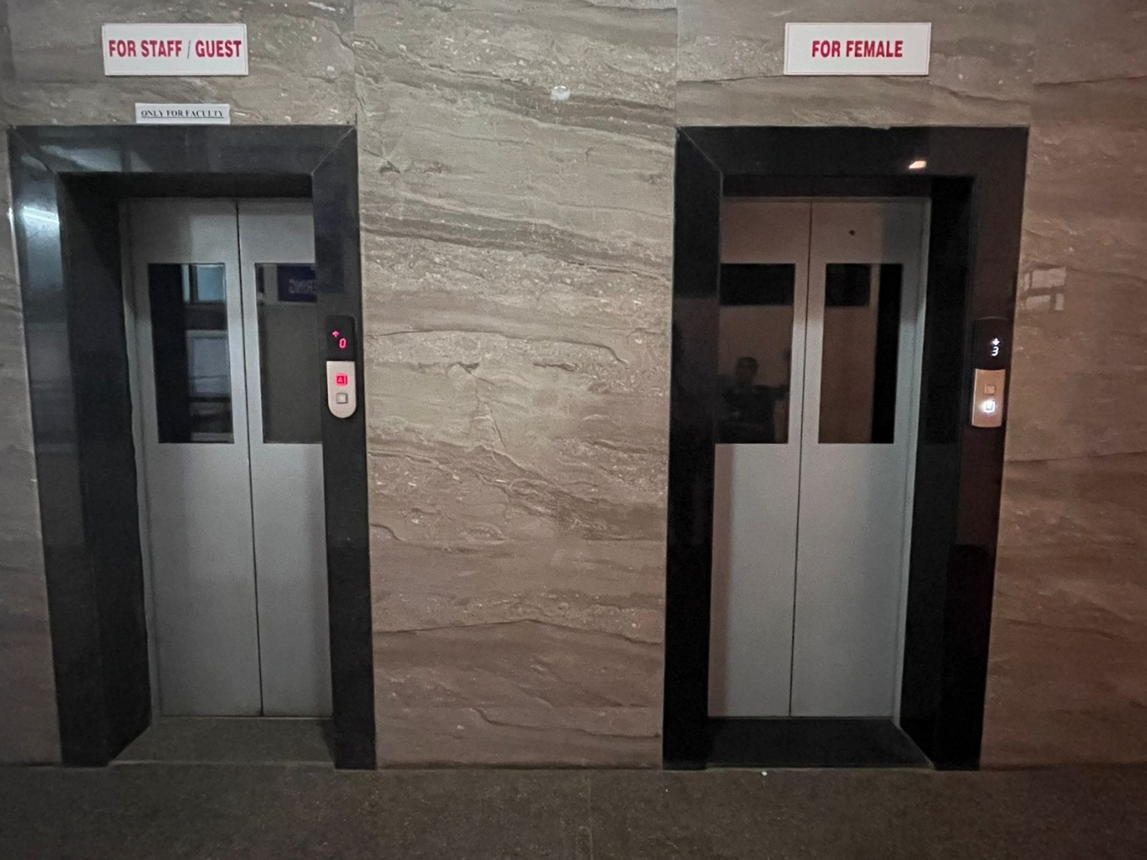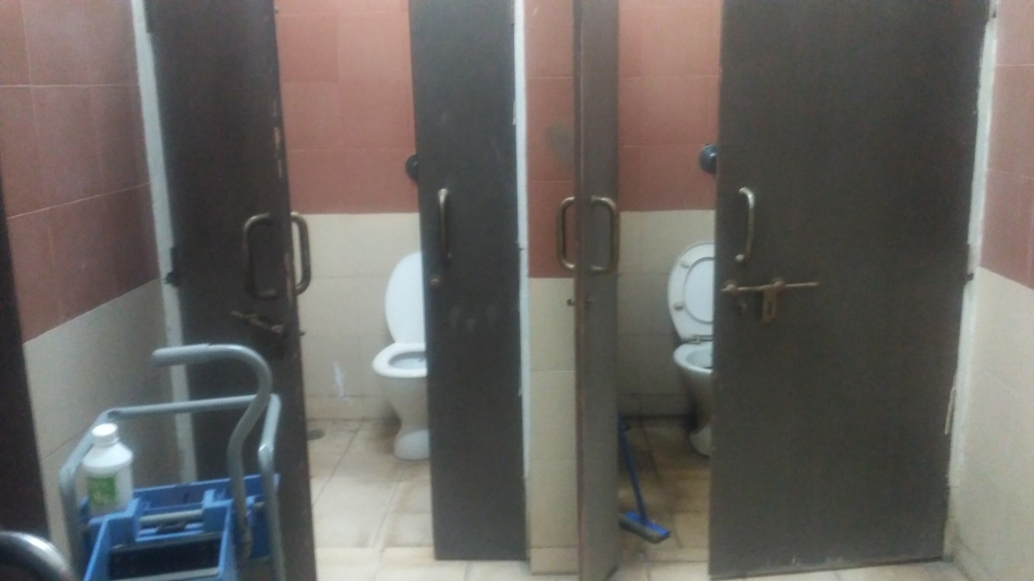

General Rules And Regulations
- Home
- Student Corner
- General Rules And Regulations

- Students has to put in satisfactory attendance of at least 75 % of the total Lectures/Periods in each Theory /Practical /Term work /Tutorials/Project work separately in each and every subject of the Semester as per the Teaching scheme of the Board.
- He/She has satisfactorily completed all the specified laboratory Practical’s / Termwork / Projects / Sessional etc. prescribed in the curriculum for the Semester /year.
- Students must attend lectures, tutorials, practical as per the time table displayed on Notice Board from time to time.
- They should not be absent for lectures, tutorials, practical, and examinations without written permission of the Principal.
- Prolong absent even in ground of ill health may also lead to term.
- Students will not be given any concession in the matters of attendance or rules regarding appearance in the college examination, disciplinary action taken to such students.
- The Identity card is meant for identifying bonafide students and is used for permitting the students to participate in various activities and programs of the college else they may be fined.
- Lost of I- Card must be immediately reported in college office and if not found then application for duplicate I-Card should be made in office.
- Every student should wear Uniform while coming to the college.
- No student is allowed to display any notices/circulars/posters/banners in the college premises without the prior permission of the principal.
- No students will be allowed to conduct any kind of political activities in the college premises.
- Students must take proper care of college property, action will be taken against the students damaging the college property and will be required to compensate for the same.
- If, for any reason continuance of a student in the college is found detrimental to the best interest of the college, the principal may ask the student to leave the college without assigning any reason and the decision will be final and binding to the student.
- Students shall not do anything inside or outside college that will interfere with college discipline or tarnish the image of the college.
- Students are not allowed to communicate any information about college matters to press.

Roles and Responsibilities of Anti Ragging Committee

- To ensure compliance with the provision of UGC regulation 2009 at the institute level.
- To monitor and oversee the performance of anti-ragging squad in prevention of ragging in the institution.
- The committee composed as above shall meet at least twice in a year to recommend preventive measures that can be adopted by the institute to prohibit, prevent and eliminate the menace of ragging in any form on campus of the Institute.
Roles and Responsibilities of Anti Ragging Squad

- The Anti-Ragging Squad Shall make surprise raids on hostels, and other places vulnerable to incidents and haing the potential for ragging and shall be empowered to inspect such places.
- It shall also be the duty of the Anti-Ragging Squad to conduct an on-the-spot inquiry into any incidents of ragging refered to it by the Head of the institution, by any staff , any student, any parent, any employee of a service provider and any other person, as the case maybe.
- The report along with observations shall be submitted to the Anti-Ragging Committee for action.
- The Anti-Ragging Squad shall conduct inquiry of incidence of ragging noticed by them during surprise raid,thoroughly observing a fair and transparent procedure & the principles of natural justice and after giving adequate opportunity to the student accused of ragging and other witnesses.
The tenure of nominated members will be renewed/reviewed annually.
Details of Antiragging Cell
The Anti-ragging committee and Anti-ragging squad have been established during Academic Year 2023-24 for the compliance of UGC Regulations on Curbing the Menace of Ragging in Higher Educational Institutions. It is for Prevention and prohibition of Ragging in the Instituion with immediate effect. The details of Anti-ragging committee and Anti-ragging Squad members shall be as follows:
- Committee List 2025-26
- Antigagging Policy Details
- Antigagging Guide-lines links
- Antiragging Video links
- National antiragging websites

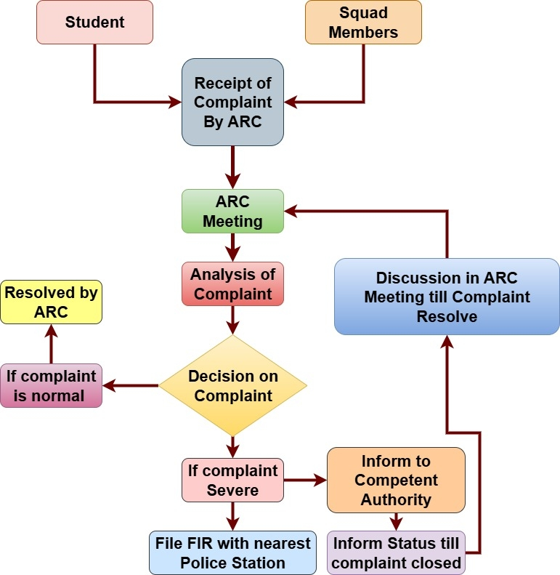
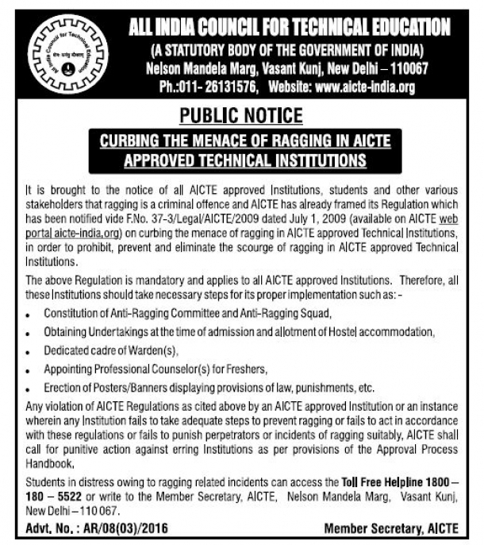
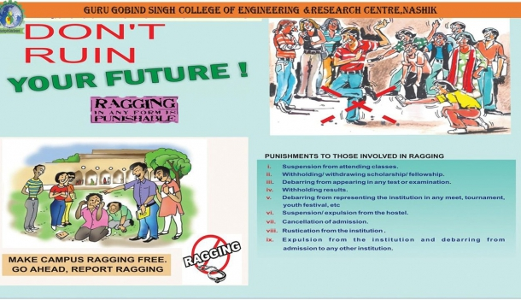

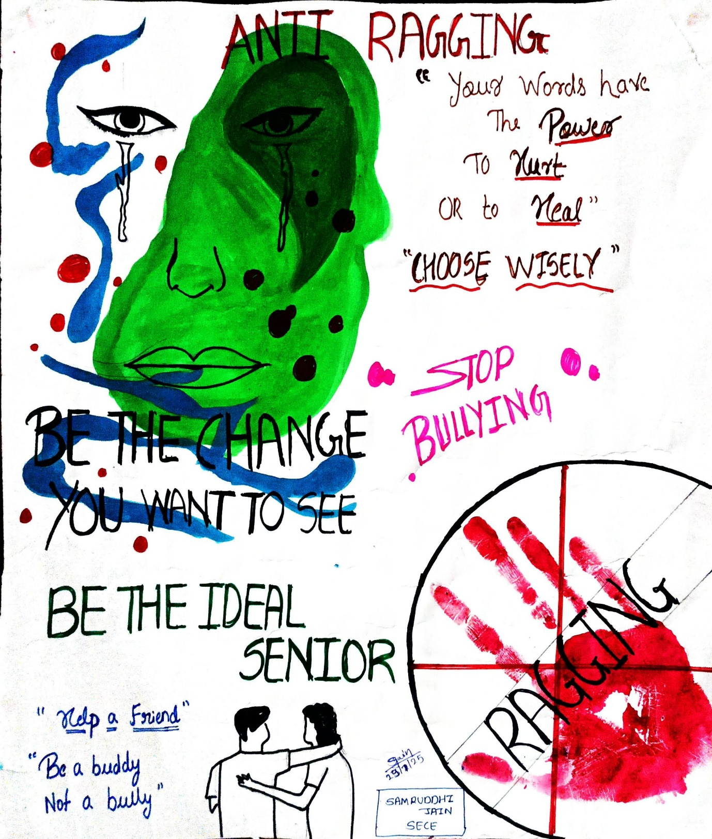

Womens Grievance Cell
- Home
- Student Corner
- Womens Grievance Cell
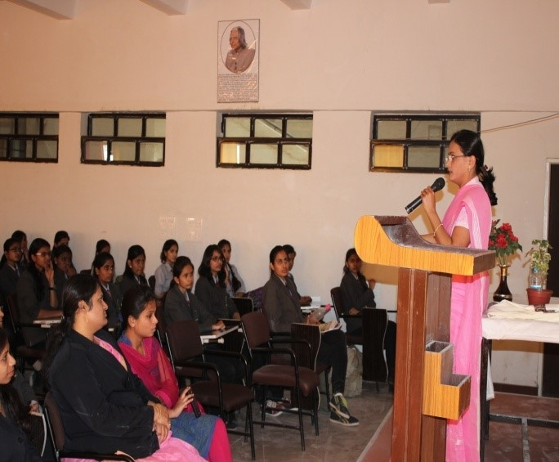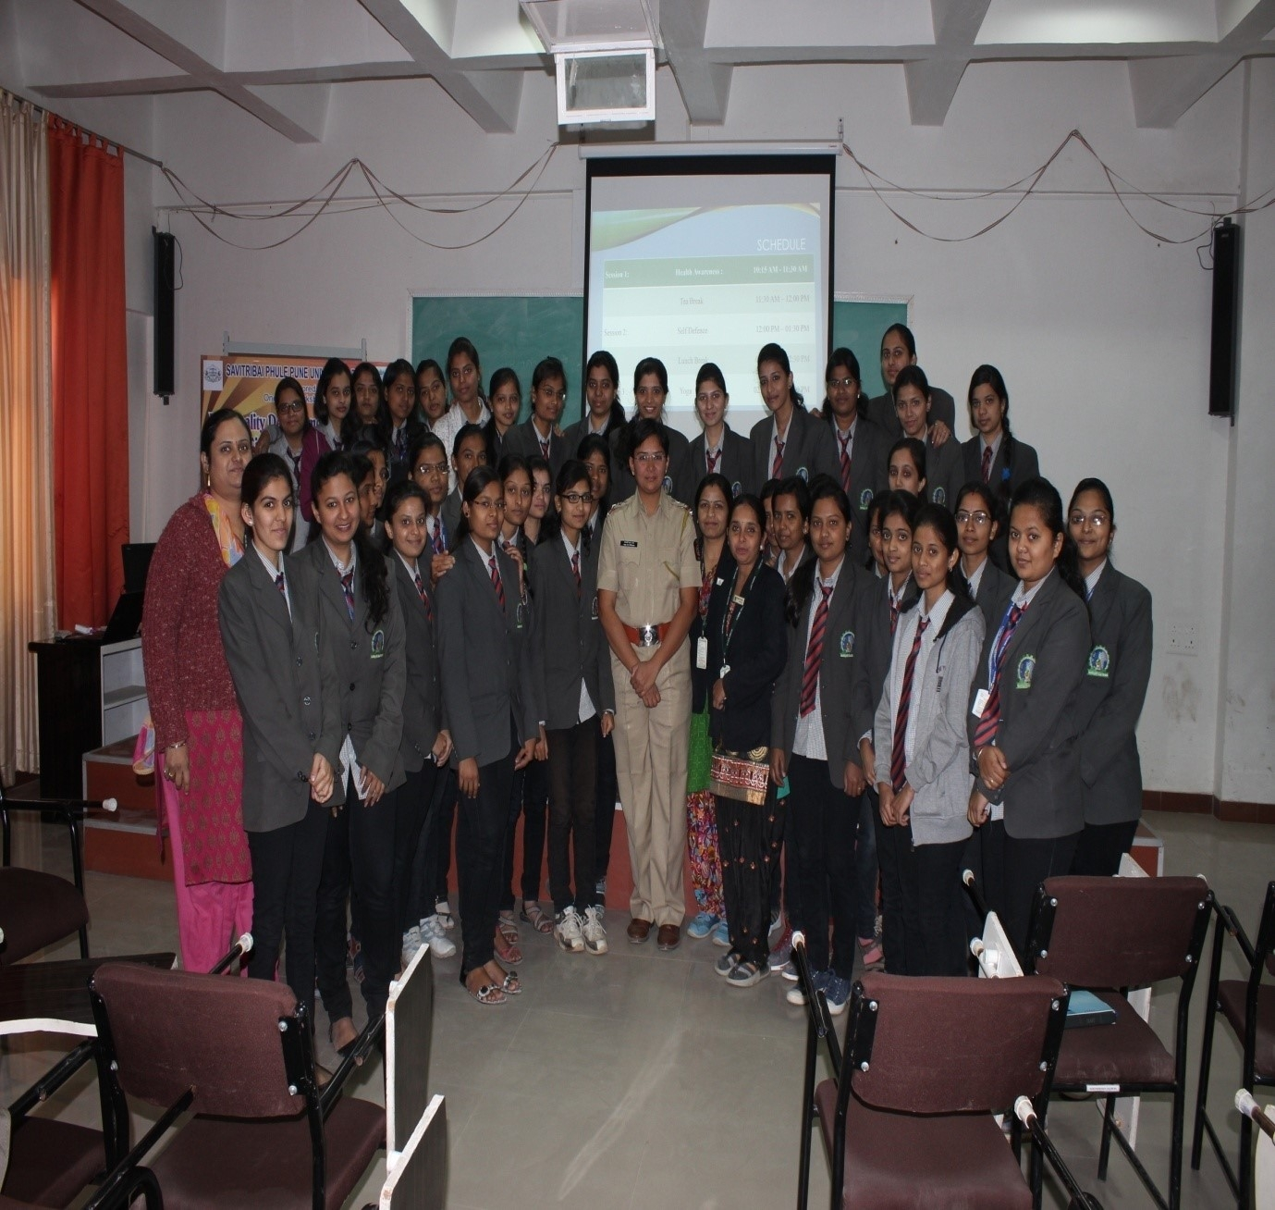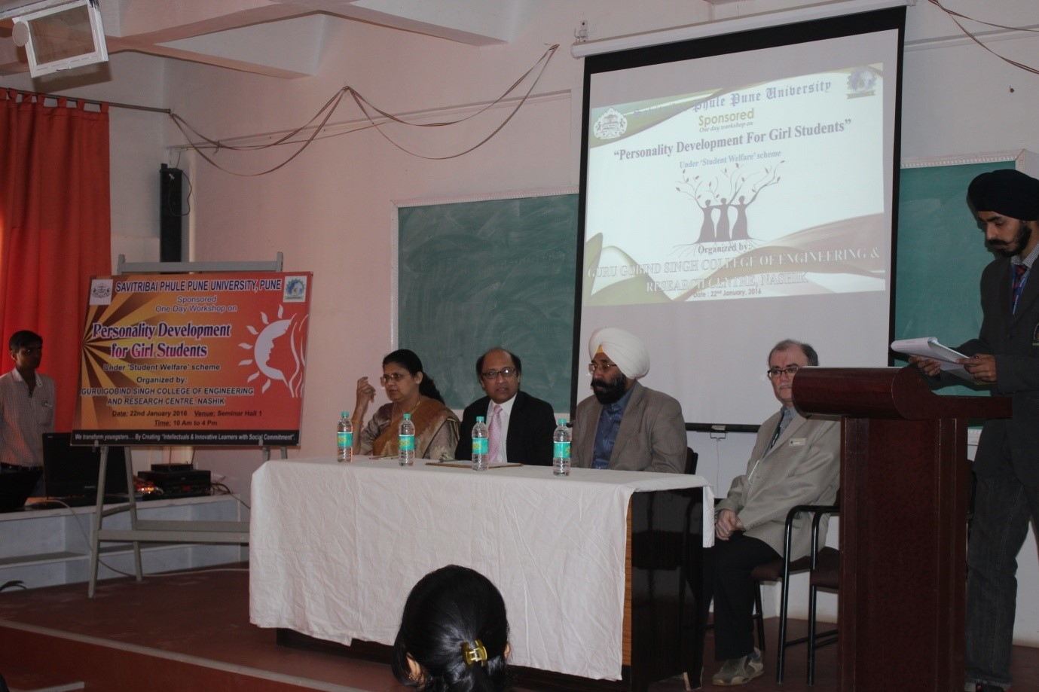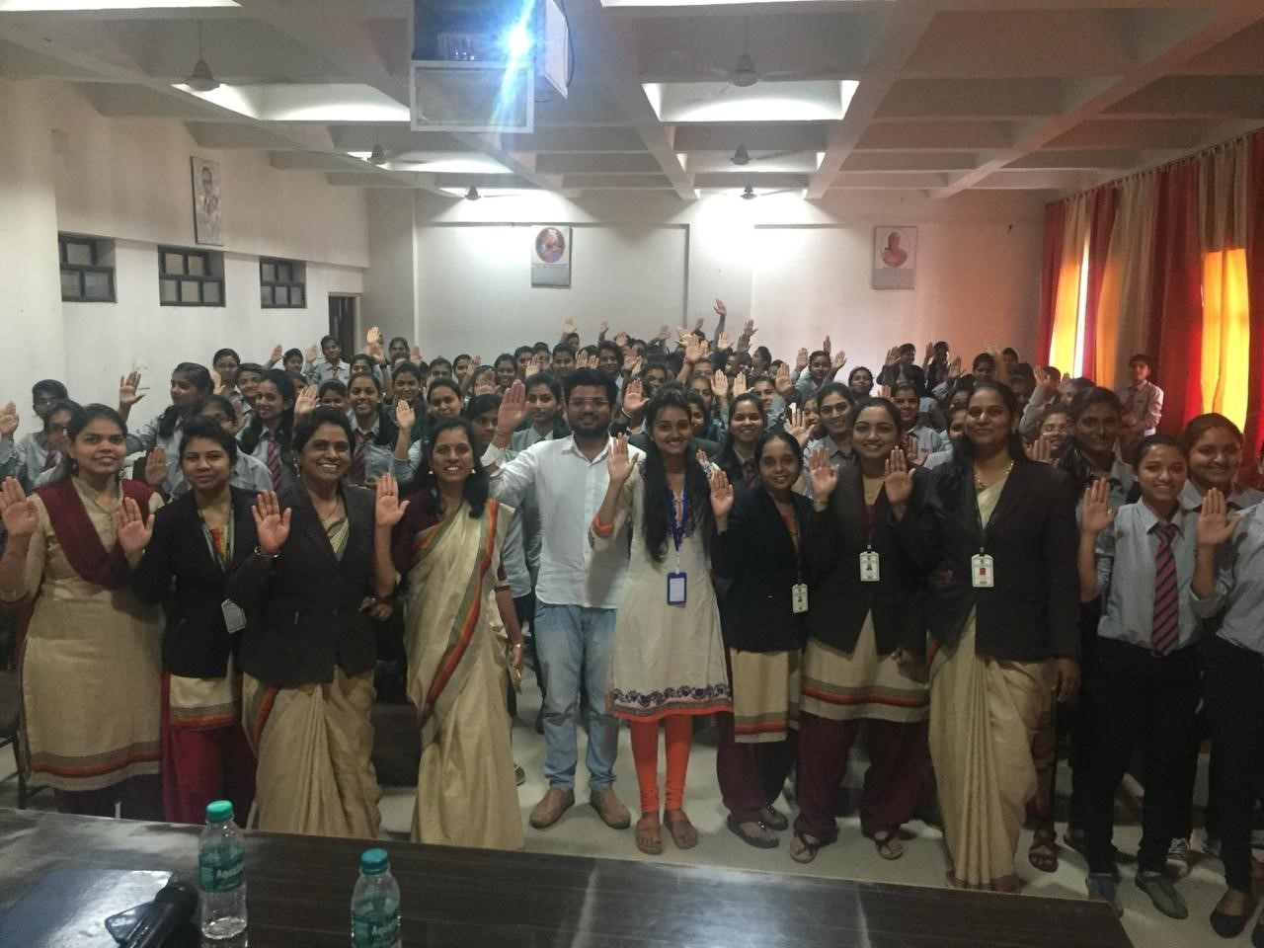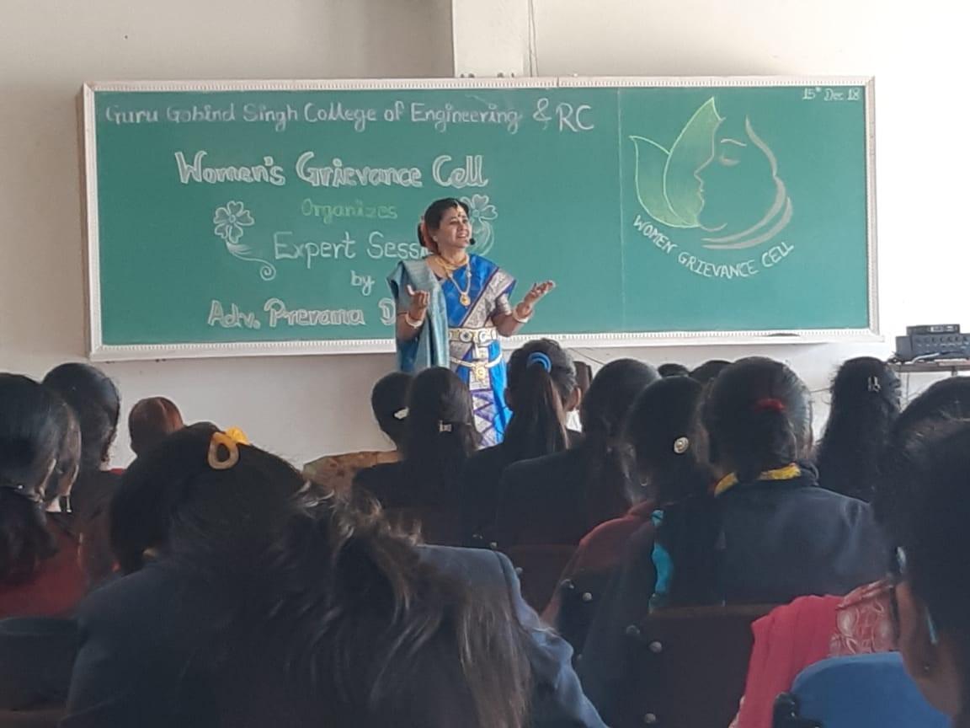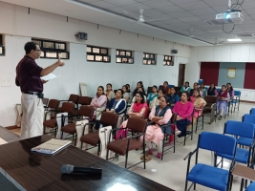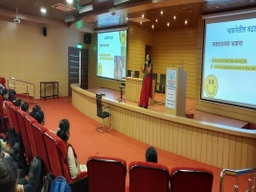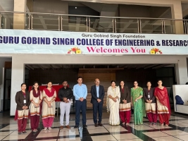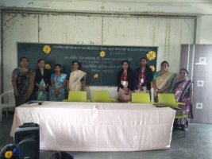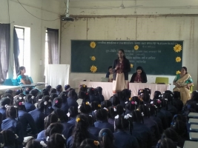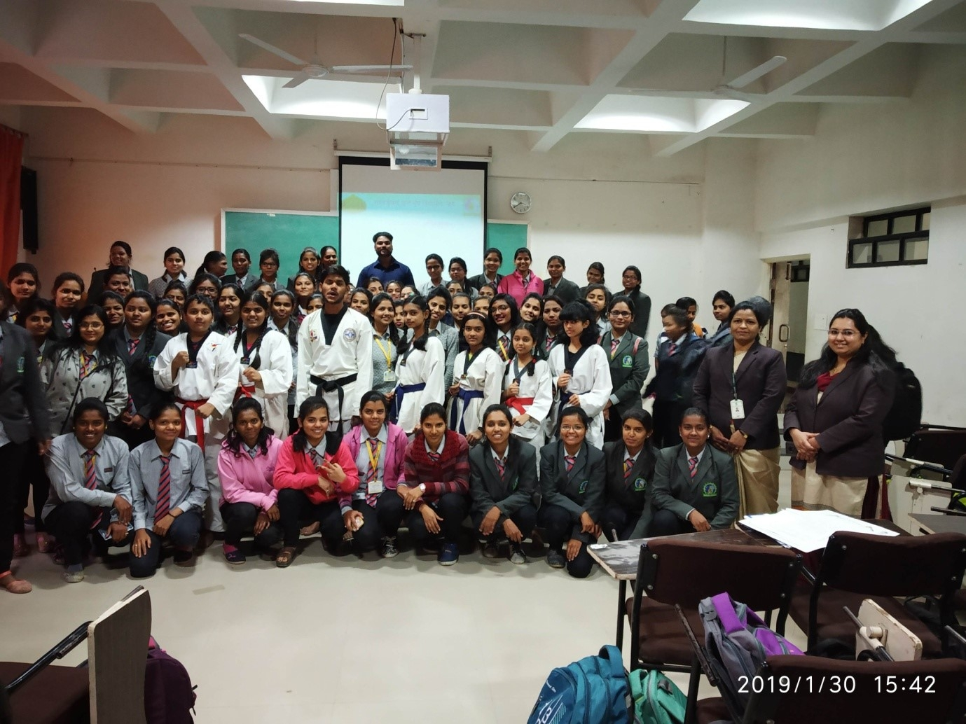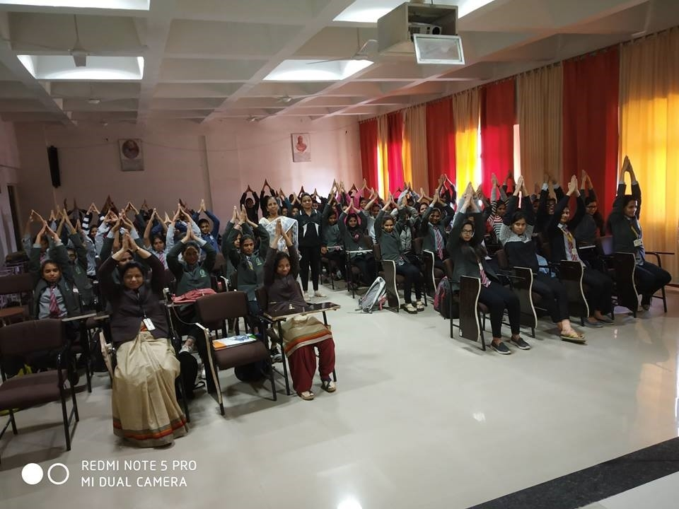
Roles and Responsibilities of Internal Committee
- The Internal Committee ensures a safe, dignified, and harassment-free environment for students, faculty, and staff.
- It receives and addresses complaints of sexual harassment within the institute.
- The Committee conducts fair, unbiased, and confidential inquiries as per prescribed guidelines.
- It recommends interim relief and appropriate disciplinary action to the institute authorities.
- The Committee organizes awareness programs and ensures compliance with statutory reporting requirements.
Committee List 2025-26
Program Organised under ICC -Academic Year 2025-26
Sr. No. | Date of Programme | Description | Name of Resource Person
1 | 21/07/2025 | One Day workshop on Woman Empowerment under quality Improvement Program sponsored by SPPU, Pune.  Session-I: “Empower her with Law: Rights, Rule and Resilience”  Session II: Your Health, Your Power” | Session-I: PI. Ms. Bhavana Mahajan, Officer In-charge, Highway Traffic Police, Nashik Division, Nashik.  Session-II: Dr. Anita Bangar, Dr. Bangar’s Sparsh Women’s Hospital & IVF Centre, Nashik
2 | 10/09/2025 | Session on "Introduction of Internal Committee/Women's Grievance Cell" in GCOERC | Mrs. Charushila Patil, Chairman, ICC, GCOERC, Nashik
3 | 26/09/2025 | Session on "Personality Development and Menstrual Hygiene” | Ms. Pratima Karkale, expert trainer, Y-connect, Mumbai
4 | 16/01/2026 | Session on "Women’s Empowerment Program-Financial Wellness Enhancement | Mr. Sameer P. Naik, Advisors Skill Development Organization, Mumbai

Examination
- Home
- Student Corner
- Examination

Institute has formed examination cell to perform all activities related to examinations of affiliating university i.e. Savitribai Phule Pune University, Pune. It is responsible for smooth and fair conduction of examinations in the institute.
The cell will be liaising between the institute and the university for all activities related to examinations. It is for helping the students to solve their difficulties/grievances related examination activities.
Examination Centre Name:Guru Gobind Singh College of Engineering and Research Centre, Nashik
College Code: 0120
Examination Centre Code: 4120
College PUN Code: CEGN020050

Examination Cell
Sr. No. | Name of Staff | Designation | Contact No.
1 | Dr. N G Nikam (Principal) | Chief Examination Controller
2 | Mr. V S Gawali | College Examination Officer | 9623910369
3 | Mr. S. S. Choudhari | Assistant Exam CEO
4. | Mr.S.S.Chandratre | Jr.Clerk (Exam Section) | 9970265651
Skill Development
- Home
- Student Corner
- Skill Development

Guru Gobind Singh Foundation has taken an initiative in the direction of development, to enhance the skill of students as a part of “Institute Industry Partnership Excellence Centre” presented by SIEMENS Ltd. and BOSCH. The motto behind this Skill Development centre is to bridge the gap between industry and academic sector with advanced training module for students in SIEMENS Ltd. and BOSCH. Training Centre.
With this initiative GGSF made the MOU with BOSCH & SIEMENS respectively to fulfill the following
Objectives:
- Prepare students for industry oriented learning through tailor made training programs.
- Knowledge sharing on Bosch and Siemens advanced automotive systems.
- Advanced training modules for students in Bosch and Siemens Training Centres.
- Help setting up the Automotive Service Solutions Lab.
- Train the trainer for lab technicians.
Training Programs of Bosch:
Sr. No. | Training Module
1 | Auto Electrical Systems (Starter, Alternator and Batteries)
2 | Vehicle Diagnostics Basics and System Diagnostics.
3 | Basic Course on Diesel Fuel Injection System
4 | Vehicle Air-Conditioning Systems and Functions.
 | Total
Training Programs of Siemens:
Sr. No. | Training Module
1 | Training Program on Low Voltage Switchgear
2 | Training Program on Basic SCADA
3 | Training Program on Basics of AC/DC Drives
4 | Training Program on Basic Automation
5 | Mechapronics
 | Total
Glimpses of Training
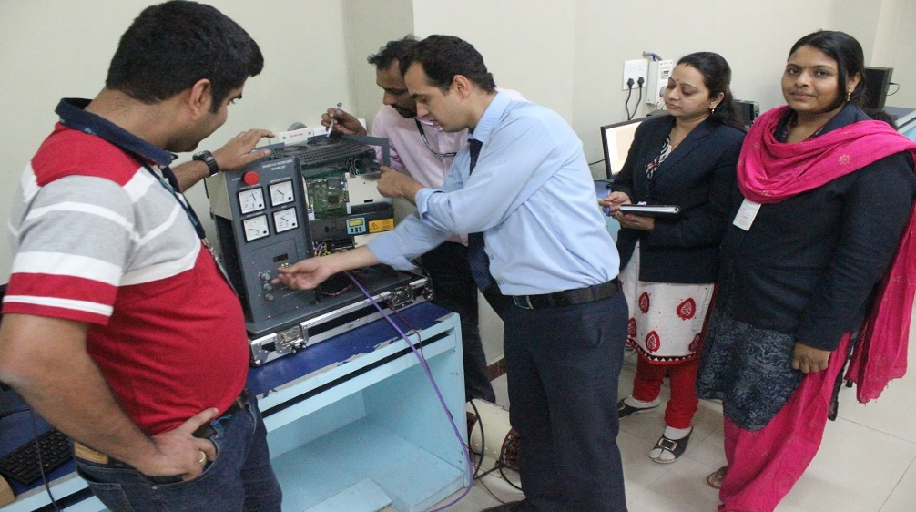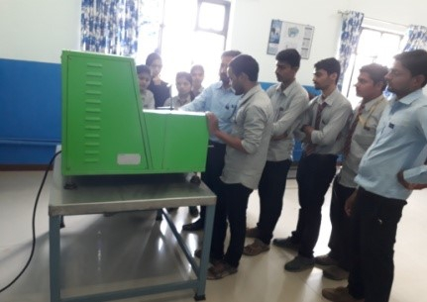
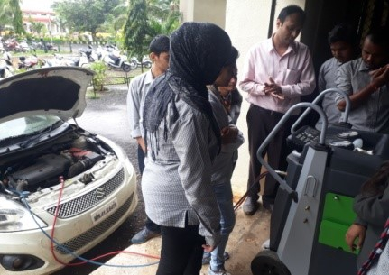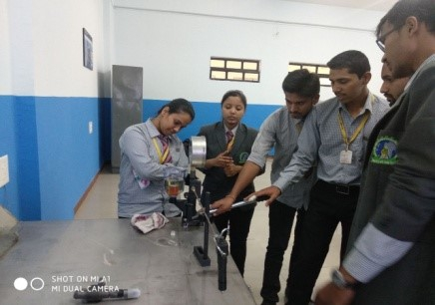
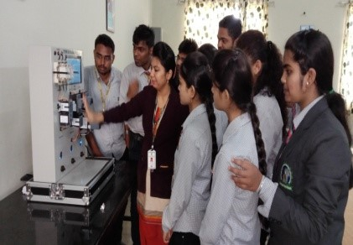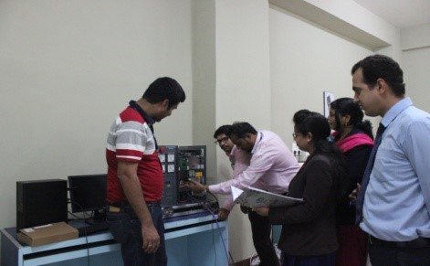
Inaugural Ceremony & Training

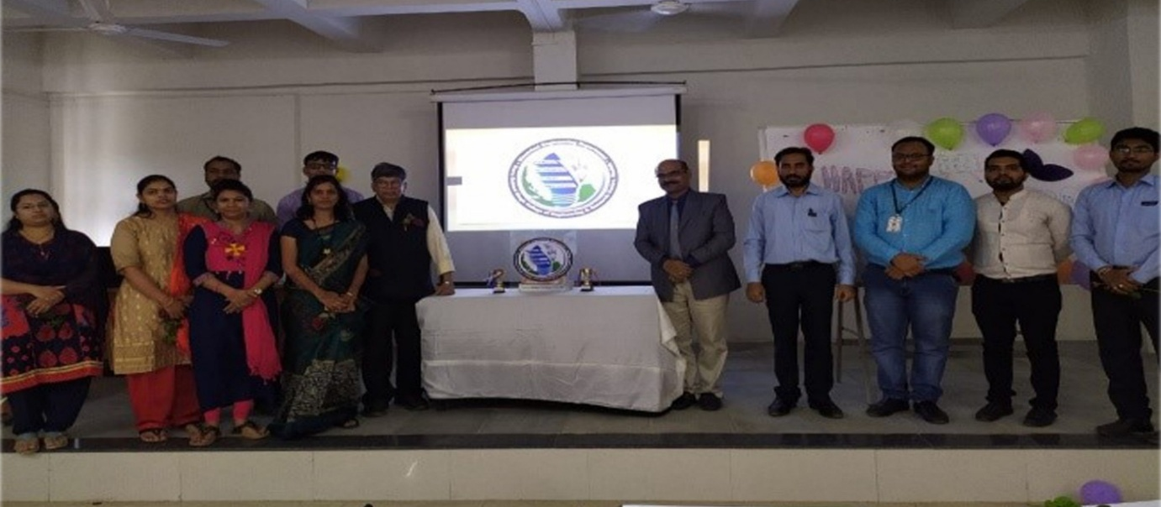

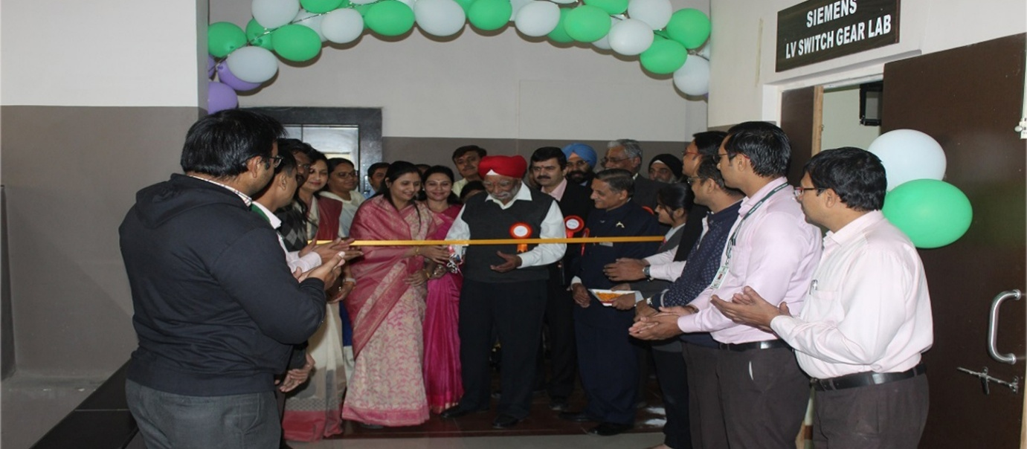

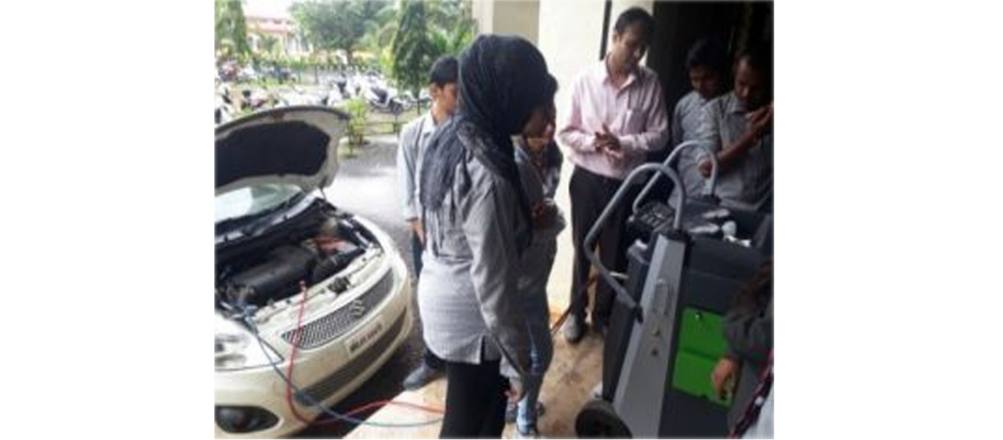

Student Welfare
- Home
- Student Corner
- Student Welfare
Introduction

Student Welfare is integralpart to all aspects of college life and the main motive of this to ensure that the institute should provide a safe and supportive environment and culture which shaped and maintained so that the experience of teaching and learning is enhanced for all students.
Objectives:
- Encouraging students to take responsibility for their own learning and behavior.
- Establishing well-managed teaching and learning environments.
- Ensuring that learning activities build on prior knowledge and experiences and are socially and culturally relevant.
- Identifying key social skills and developing plans for all students to acquire them, or make progress towards them.
- Ensuring that gender and equity issues are recognized and addressed across the curriculum.
Schemes:

- Earn & Learn Scheme
The main objective of the scheme is to develop a student as a multifaceted personality with academic excellence and a commitment to an egalitarian society. This scheme will help students to fill up the gaps between Rural Bharat and urban India.This scheme is basically undertaken for the benefit of students coming from the rural areas, which are economically not Sound backward, intelligent, and meritorious but cannot afford higher education, needy for financialsupport.
It inculcates in the student the idea that no work is big or small and develops a work culture with the right aptitude. This is a vision of keeping our youth gainfully employed as well as to contribute from civil society. This is a paradigm shift in the way we see higher education. This will make higher education accessible and available to the poor, meritorious and the marginalized.
Technical work includes:
Students should equipped their Knowledge theoretical as well as technically which helps to developed interpersonal relationship with society.
In this scheme students will participating to enhance their various technical knowledge like works of computers, office machines such as photocopying etc. or even working at administrative work , while field work includes working in the garden, looking after newly planted trees, play grounds, cleanliness of the campus etc. Each student is expected to work for three hours daily. Students working under this scheme are paid an honorarium of Rs.30 per hour as per the revised rates effective July 2015. Payment is made as per the attendance sheet, which is to be maintained by the institute. The students are requested to open a bank account at their respective places and cheques make payments.
- Special Guidance Scheme
The basic objective of this scheme is to help those students who are deprived of the latest knowledge of the subject they undertake at the first year level. Secondly, this scheme is helpful for students for their overall development. Thirdly, to offer guidance to students in their career choices and the relevant subjects to be pursued by them to attain their best potential
- Personality Development of Girl Students
This is a scheme introduced to develop the confidence and personality of a girls who comes from the rural areas and are deprived sections of society. The marginalization and deprivation is double if you are a woman and from the backward or scheduled castes. The main objective of this scheme is to develop a critical mind, self-confidence and a commitment to society. The girls students are given training in health, law, and social activities. They are also given training in self-employment and all possible other activities that enhance her social confidence. The main objectives of this scheme includes development of self-confidence how to defend oneself in any situation, training in self-defense and finally make them fearless and be ready to face any unwanted situation. This scheme is open to all regular girls students.

Gcoerc's Students Club
Institute-level clubs are student groups that focus on activities outside of regular studies, like sports, arts, technology, and culture. They give students a chance to explore their interests, work on projects, and organize events. Being part of a club helps students make new friends, build skills like teamwork and leadership, and have fun while learning. These clubs often host workshops, competitions, and social events, making college life more exciting and meaningful.
Sr.No. | Name of Club | Name of Coordinator | Committee List | Activity 2023-24 | Activity 2024-25 | Activity 2024-25 | Activity 2025-26
1. | Sahas and Saksham | Mr.M.G.Koli and Mr.D.S.Desale | 2023-25 | Report 1  Report 2
2. | Indo-Fest | Mrs.Nishigandha Khaire | 2023-2024  2024-2025  2025-2026 | Report 2023-24 | Report 2024-25 | Report 2025-26
3. | Google Developer | Dr.U.D.Butkar and Ms.P.K.Bachhav | 2023-2024 | Report 2023-24
4. | Tech-Fest | Mr.S.M.More | Committee List
5. | Go Green (Eco Friendly) | Mr.P.B.Shinde | Committee List | Report 2023-24 | Report 2024-25
6. | Sports and Yoga Meditation | Mr.C.G.Joshi | 2023-2024  2024-2025 | Report 2023-24
7. | Finance & Economy | Mr.A.R.Jain | 2023-2024  2024-2025 | Report 2023-24 | Report 2024-25
8. | Astha Club for Institute Social Responsibility | Mr.V.S.Gawali | 2021-2024  2024-2025 | Report 2023-24
9. | Electroal Literacy | Mr.Deepak Patil and Mr.Piyush Kulkarni | 2023-2024  2024-2025 | Report 2023-24 | Report 2024-25
10. | Art Club | Mr.Sandip Patil | 2024-25 | Report 2023-24 | Report 2024-25
11. | Electrical Vehicle | Mr.S.M.More | 2023-2024  2025-2026 | Report 2023-24 |  |  | Report 2025-26
12. | Digital Literacy and Cyber Security | Mr.P.R.Pachorkar | 2024-2025
13. | Automotive Club | Mr.V.S.Gawali | 2023-2024  2024-2025  2025-2026 |  |  |  | Report 2025-26
14. | Renewable Energy Club (REC) | Dr.Milind Patil and Mr.Vishal Dhore | 2023-2024 | Report 2023-24
15. | Coding Club | Ms.P.K.Bachhav | 2023-2024  2024-2025  2025-2026 | Report 2023-24 | Activity Calender 2024-25 |  | Report 2025-26
16 | Yuva Career Club | Mr.P.R.Kulkarni | Committee List

Gcoerc's Students Club
Institute-level clubs are student groups that focus on activities outside of regular studies, like sports, arts, technology, and culture. They give students a chance to explore their interests, work on projects, and organize events. Being part of a club helps students make new friends, build skills like teamwork and leadership, and have fun while learning. These clubs often host workshops, competitions, and social events, making college life more exciting and meaningful.
Sr.No. | Name of Club | Name of Coordinator | Committee List | Activity 2023-24 | Activity 2024-25 | Activity 2024-25 | Activity 2025-26
1. | Sahas and Saksham | Mr.M.G.Koli and Mr.D.S.Desale | 2023-25 | Report 1  Report 2
2. | Indo-Fest | Mrs.Nishigandha Khaire | 2023-2024  2024-2025  2025-2026 | Report 2023-24 | Report 2024-25 | Report 2025-26
3. | Google Developer | Dr.U.D.Butkar and Ms.P.K.Bachhav | 2023-2024 | Report 2023-24
4. | Tech-Fest | Mr.S.M.More | Committee List
5. | Go Green (Eco Friendly) | Mr.P.B.Shinde | Committee List | Report 2023-24 | Report 2024-25
6. | Sports and Yoga Meditation | Mr.C.G.Joshi | 2023-2024  2024-2025 | Report 2023-24
7. | Finance & Economy | Mr.A.R.Jain | 2023-2024  2024-2025 | Report 2023-24 | Report 2024-25
8. | Astha Club for Institute Social Responsibility | Mr.V.S.Gawali | 2021-2024  2024-2025 | Report 2023-24
9. | Electroal Literacy | Mr.Deepak Patil and Mr.Piyush Kulkarni | 2023-2024  2024-2025 | Report 2023-24 | Report 2024-25
10. | Art Club | Mr.Sandip Patil | 2024-25 | Report 2023-24 | Report 2024-25
11. | Electrical Vehicle | Mr.S.M.More | 2023-2024  2025-2026 | Report 2023-24 |  |  | Report 2025-26
12. | Digital Literacy and Cyber Security | Mr.P.R.Pachorkar | 2024-2025
13. | Automotive Club | Mr.V.S.Gawali | 2023-2024  2024-2025  2025-2026 |  |  |  | Report 2025-26
14. | Renewable Energy Club (REC) | Dr.Milind Patil and Mr.Vishal Dhore | 2023-2024 | Report 2023-24
15. | Coding Club | Ms.P.K.Bachhav | 2023-2024  2024-2025  2025-2026 | Report 2023-24 | Activity Calender 2024-25 |  | Report 2025-26
16 | Yuva Career Club | Mr.P.R.Kulkarni | Committee List

Rules

Library Rules for Circulation:
- Library users must bring their ID card & must sign in the entry register while entering in the library.
- Library facility is available to following :
  - Students&Faculty /Staff of the college
  - Faculty & staff members of the sister concerned Institutions
  - External guests, subject to an approval by the Principal.
3. No personal belonging including books are allowed inside the library.
4. Maximum number of books to be issued to the member is as below:
- Student : Four books
- Faculty members : Eight books
- Non-Teaching Staff : Two books
5. Students will be issued books for a maximum period of 15 days. Overdue books will charged as per rules in force.
6. The book-bank facility is available only for the regular students and for further details students may contact librarian.
7. The library reserves the right to recall back any issued book/document at any time even before the due date.
8. Users should verify the physical condition of the book/document during its issuing. They will be held responsible for any damage caused thereafter.
9. Scribbling/marking in the books, magazines, journals, and newspapers is not permitted.
10. Safe return of book/ document is the sole responsibility of user being lost or damaged he/she will have to compensated by replacement or payment.
11. No material from the library should be taken out without prior permission.
12. Periodicals and Journals has to be referred in the Library as they are not to be issued on individual’s name.
13. Request for usage of library resources by alumni of any other external student / public person will be consider case to case as & when approached.
14. Stealing or attempting to steal a library document or any of the library property is an offence will attract to appropriate disciplinary action.
15. The discretion/decision of the Principal, on any matter pertaining to the library services shall be final and will be binding on all library users.
LIBRARY RULES FOR -DIGITAL LIBRARY
1. Student should wear college I-Card/uniform to avail digital library facility and produce it, as and when asked by the library staff.
2. Digital library computers should be used for only for the purpose of educational and research activities.
3. Members should not share their internet access ID and passwords with other users.
4. Users should use computer resources in an effective, efficient, appropriate, ethical and legal manner.
5. Upon completion of their session users should logout the computer and should remove extraneous materials and papers before leaving.
6. Any violations of the above stated rules and regulations may results in banning of entry to library.
- Photocopying service is available to all members and external guests on nominal charges.
- All photocopying must comply with the Copyright Legislation
- Some material in Library cannot be photocopied because of copyright laws, unhealthy condition of book and donor restriction.
- The discretion/decision of the Principal, on pertaining to any matter on photocopy services will be final and binding on.
LIBRARY RULES FOR READING ROOM
1. The reading room will remain open from 08:30 am to 05:30 pm. In addition during semester examinations working hours may be extended as per requirement.
2. Reading room facility is available for the regular as well as ex-students.
3. It is mandatory to sign entry register before entering reading room.
4. Student should display college I-card/uniform to avail reading room facility and produce it, as and when asked by the library staff.
5. All personal belongings should be deposited in property counter. They are advised not to leave cash and other valuable items in their belongings and library shall not take any responsibility for the same.
6. Strict silence, discipline and decorum should be maintained in the library.
7. Use of personal mobile phones/laptops is allowed only for the educational purpose.
8. Handle all the library property carefully to avoid damage.
9. Beverages and eatables are not allowed inside the library.
10. Request for usage of library resources by alumni of any other external student / public person will be consider case to case as & when approached.
11. Suggestions on all aspects of the library services are highly appreciated.
12. Violation of any of these rules and regulations will lead to disciplinary action.
13. The discretion/decision of the Principal, on all matter concerning library is binding to all users.
14. Follow rules of Circulation room & digital library displayed separately while using these facilities.

Placement:
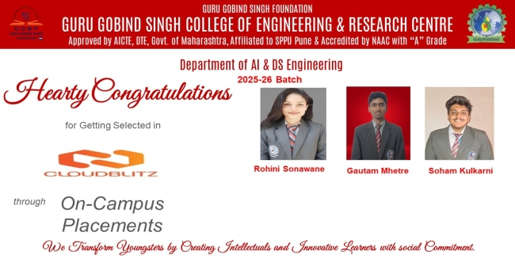

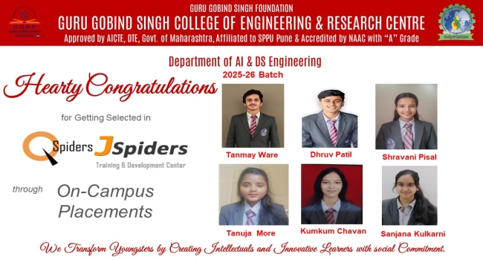

Research.
- Home
- Research.
1. Study of Ground water Flow Using Ultrasonic Pulse Velocity - Click here for details
2. An Experimental Study for Electricity Generation by applying potential head of waste water flowing down through vertical drainpipes of High- Rise Building by using systems of very small Turbines -
Click here for details
3. A Development of Resin-Based Lightweight Composite Material for Automobile and Railway Applications. - Click here for details
4. Optimal Cropping Planning Under Changing Climate - Click here for details
5. AI Presentation Tool using Gesture Recognition - Click here for details
6.Design and Development of Cattle Ambulance structure with safe loading and unloading Adjustment - Click here for details
7. Design and manufacturing of flexible cage for Cattle Transport vehicle with loading adjustment - Click here for details
8.Design and Development of Cow Lift for the Downer Cattle - Click here for details

UGC Public Self Disclosure
- Home
- UGC Public Self Disclosure
UGC Public Self Disclosure
Guru Gobind Singh College of Engineering and Research Centre, Nashik
A compliance report according to the UGC guidelines on Public Self Disclosure.
Institute Website: https://engg.ggsf.edu.in/index.php
Sr. No. | Name of Main Tab | Name of Sub Tab | Web-Link
A. About HEI
1 | About Us : Overview | About Institute | View
1 | About Us : Overview | Institute Vision Mission | View
1 | About Us : Overview | Organization Chart | View
1 | About Us : Overview | Principals Desk | View
1 | About Us : Overview | Details of FRA and Fees Structure | View
1 | About Us : Overview | Mandatory Disclosure | View
1 | About Us : Overview | Details of Institute Approvals (AICTE, University Affiliation, AISHE) | View
1 | About Us : Overview | Financial Details | View
1 | About Us : Overview | Governing Body | View
1 | About Us : Overview | Details of Administrative Staff | View
1 | About Us : Overview | Policy Guidelines | View
1 | About Us : Overview | Institute Development Plan | View
2 | Act and Statutes or MOA | Not applicable (Institute is affiliated to University) | Not Applicable
3 | Institutional Development Plan | Institutional Development Plan | View
4 | Constitute Unit / Affiliated Colleges | Not applicable (Institute is affiliated to University) | Not Applicable
5 | Accreditation / Ranking Status (NAAC, NBA, NIRF) | NAAC Cycle 1 | View
5 | Accreditation / Ranking Status (NAAC, NBA, NIRF) | NAAC Cycle 2 | View
5 | Accreditation / Ranking Status (NAAC, NBA, NIRF) | NBA | View
6 | Recognition / Approval | Not applicable (Institute is affiliated to University) | Not Applicable
7 | Annual Reports – Balance Sheet | Annual Reports – Balance Sheet | View
8 | Sponsoring Body | Not applicable | Not Applicable
B. Administration
1 | Administration | Chancellor | Not Applicable
2 | Administration | Pro Chancellor | Not Applicable
3 | Administration | Vice Chancellor | Not Applicable
4 | Administration | Registrar | View
5 | Administration | Principal | View
6 | Administration | Finance Officer | Not Applicable
7 | Administration | Controller of Examination | Not Applicable
8 | Administration | Chief Vigilance Officer | Not Applicable
9 | Administration | Ombudsperson | Not Applicable
10 | Administration | Executive Council / Board of Governors / Board of Management / Academic Council | View
11 | Administration | Internal Complaint Committee | View
12 | Administration | Academic Leadership – Artificial Intelligence & Data Science Engineering | View
12 | Administration | Academic Leadership – Automation and Robotics Engineering | View
12 | Administration | Academic Leadership – Civil Engineering | View
12 | Administration | Academic Leadership – Computer Engineering | View
12 | Administration | Academic Leadership – Electrical Engineering | View
12 | Administration | Academic Leadership – Mechanical Engineering | View
12 | Administration | Academic Leadership – Management Studies | View
C. Academic
1 | Academic | Details of Academic Programs | View
2 | Academic | Academic Calendar | View
3 | Academic | Departments | View
4 | Academic | List of UGC-recognized ODL Program | Not Applicable
5 | Academic | Internal Quality Assurance Cell (IQAC) | View
6 | Academic | Academic Collaborations – List of MoU | View
D. Admissions & Fee
1 | Admissions & Fee | Prospectus – Admission Brochure | View
1 | Admissions & Fee | Prospectus – Fees Structure | View
2 | Admissions & Fee | Admission Process – Home Page | View
2 | Admissions & Fee | Details of Program Offered | View
2 | Admissions & Fee | Details of Admission Process | View
2 | Admissions & Fee | Details of Admission Documents Required | View
2 | Admissions & Fee | Admission Brochure | View
2 | Admissions & Fee | Details of Admission Notices | View
2 | Admissions & Fee | Admission Enquiry | View
3 | Admissions & Fee | Fee Refund Policy | View
E. Research
1 | Research & Development Cell | Research Committee | View
1 | Research & Development Cell | Details of Patents (IPR Cell) | View
1 | Research & Development Cell | Details of Research Proposals | View
1 | Research & Development Cell | Details of Research Publications | View
1 | Research & Development Cell | Details of Call for Research Proposals | View
1 | Research & Development Cell | Details of In-house Research | View
1 | Research & Development Cell | Details of FDPs | View
2 | Incubation Center / Start-ups / Entrepreneurship Cell | Details of Institution's Innovation Council | View
Central Facility
3 | Central Facility | Library Details | View
3 | Central Facility | Library Details – Second Link | View
3 | Central Facility | Library Rules | View
3 | Central Facility | Library e-Resources | View
3 | Central Facility | Library Infrastructure | View
3 | Central Facility | Library Enrichment | View
3 | Central Facility | Library Staff Details | View
3 | Central Facility | Placement Infrastructure | View
3 | Central Facility | Placement Committee | View
3 | Central Facility | Details of Placement Officer | View
3 | Central Facility | Details of Training | View
3 | Central Facility | Details of Higher Education and Entrepreneurship | View
3 | Central Facility | Student Placement Details | View
3 | Central Facility | Sports Facility | View
3 | Central Facility | Computer Centre Facility | View
3 | Central Facility | Canteen Facility | View
3 | Central Facility | Auditorium and Seminar Hall Facility | View
3 | Central Facility | Facilities for Persons with Disabilities | View
3 | Central Facility | Cultural Facility | View
3 | Central Facility | Skill Development Facility | View
F. Student Life
1 | Student Life | Sports Facilities | View
2 | Student Life | NCC / NSS | View
3 | Student Life | Hostel Details | Facility Not Available
4 | Student Life | Placement Infrastructure | View
4 | Student Life | Placement Committee | View
4 | Student Life | Details of Placement Officer | View
4 | Student Life | Details of Training | View
4 | Student Life | Details of Higher Education and Entrepreneurship | View
4 | Student Life | Student Placement Details | View
5 | Student Life | Student Grievance Redressal Committee (SGRC) | View
5 | Student Life | Online Grievance Submission | View
6 | Student Life | Health Facilities | View
7 | Student Life | Internal Complaint Committee | View
8 | Student Life | Anti-Ragging Cell | View
9 | Student Life | Equal Opportunity Cell | View
10 | Student Life | Socio-Economically Disadvantaged Groups Cell (SEDG) | View
11 | Student Life | Facilities for Differently-Abled | View
G. Alumni
1 | Alumni Association with details | Alumni Body | View
1 | Alumni Association with details | Registered Alumni | View
1 | Alumni Association with details | Alumni Meet and Activities | View
1 | Alumni Association with details | Distinguished Alumni | View
1 | Alumni Association with details | Alumni Feedback | View
1 | Alumni Association with details | Alumni Photo Gallery | View
H. Information Corner
1 | Information Corner | RTI – Details of Central Public Information Officer (CPIO) and Appellate Authority | View
2 | Information Corner | Circular and Notices | View
3 | Information Corner | Announcement | View
4 | Information Corner | Newsletters | View
5 | Information Corner | News, Recent Events & Achievement | View
6 | Information Corner | Job Opening | View
7 | Information Corner | Reservation Roster | View
8 | Information Corner | Study in India | Not Applicable
9 | Information Corner | Admission Procedure and Facilities Provided to International Students | Not Applicable
I. Picture Gallery
1 | Picture Gallery | Institute Website | View
1 | Picture Gallery | Regular Picture Gallery | View
J. Contact Us
1 | Contact Us | Contact Us | View
Contact Us
- Home
- Contact Us
Visit Us :

Contact Detail's :
: 2372666
: 0253237276
: +91 7768004583
+91
Address : Khalsa Educational Complex, Guru Gobind Singh Marg, Wadala-Pathardi Road, Indira Nagar Annexe, Nashik-422009
Email :gcoerc.nashik@ggsf.edu.in
Website : www.ggsf.edu.in

Full Name* :
Email Id* :
Contact No* :
Select Year * :
First Year
Direct Second Year
Select Course* : --Select Course-- Civil Engineering Computer Engineering Electrical Engineering Mechanical Engineering Artificial Intelligence & Data Science Automation & Robotics Bachelor of Business Administration (BBA) Master of Business Administration (MBA) ME Computer (Artificial Intelligence and Data Science) ME Mechanical (Automation and Robotics)
Write Your Query * :
Submit

